KLAIPEDA UNIVERSITY

Faculty of Marine Technology and Natural Sciences

Department of Informatics and Statistics

**Improving Quality of Ship Detection from Satellite Images of the Baltic Sea by Optimizing Hyperparameters of Machine Learning Algorithms**

Bachelor’s Final Thesis

Author: JNIN21AK, stud. Nikita Ferents

Supervisor: prof. dr. Vitalij Denisov

Klaipėda, 2024

**BAKALAURO (MAGISTRO) BAIGIAMOJO DARBO LYDRAŠČIO FORMA**

*Pildo bakalauro baigiamojo darbo autorius*

.......................................................................................Nikita Ferents..................................................................

(bakalauro/magistro baigiamojo darbo autoriaus vardas, pavardė)

Baigiamojo darbo tema: LT: Laivų aptikimo iš Baltijos jūros palydovinių vaizdų kokybės gerinimas optimizuojant mašininio mokymosi algoritmų hiperparametrus.

(bakalauro/magistro baigiamojo darbo pavadinimas lietuvių kalba)

EN: Improving Quality of Ship Detection from Satellite Images of the Baltic Sea by Optimizing Hyperparameters of Machine Learning Algorithms.

(bakalauro/magistro baigiamojo darbo pavadinimas lietuvių kalba)

**Patvirtinu, kad bakalauro baigiamasis darbas parašytas savarankiškai, nepažeidžiant kitiems asmenims priklausančių autorių teisių, visas baigiamasis bakalauro/magistro darbas ar jo dalis nebuvo panaudotas Klaipėdos universitete ir kitose aukštosiose mokyklose.**

(bakalauro/ magistro baigiamojo darbo autoriaus ir parašas)

**Sutinku, kad bakalauro baigiamasis darbas būtų naudojamas neatlygintinai 5 m. Klaipėdos universiteto studijų procese.**

(bakalauro/ magistro baigiamojo darbo autoriaus ir parašas)

*Pildo bakalauro baigiamojo darbo vadovas*

**Bakalauro/magistro baigiamąjį darbą ginti......................................................................................**

(įrašyti - **leidžiu** arba **neleidžiu**)

2024-12-12 ..........................................prof. dr. Vitalij Denisov

(data) (bakalauro/magistro baigiamojo darbo vadovo vardas, pavardė ir parašas)

*Pildo katedros, kuruojančios studijų programa, administratorius (sekretorius)*

**Baigimasis darbas įregistruotas katedroje**  2024-12-23

(data)

Laima Brazdeikienė

(katedros sekretorės vardas, pavardė ir parašas)

*Pildo katedros, kuruojančios studijų programą, vedėjas*

**Bakalauro/magistro baigiamąjį darbą ginti**...............................................................................

(įrašyti - **leidžiu** arba **neleidžiu**)

2024................................ doc. dr. Mindaugas Kurmis....................................................

(data) (katedros vedėjo vardas, pavardė ir parašas)

**Recenzentu(-ais) skiriu.............**............................................................................................................. **…………**………………………………………………………………………………………………

(įrašyti recenzento(ų) vardą, pavardę)

2024................................ doc. dr. Mindaugas Kurmis....................................................

(data) (katedros vedėjo vardas, pavardė ir parašas)

# SUMMARY

This bachelor’s thesis explores the optimization of machine learning algorithms for automating ship detection in the Baltic Sea region, focusing on improving model accuracy through hyperparameter optimization. The study uses satellite imagery from the Copernicus Data Space System to address maritime surveillance challenges and improve port operations while minimizing human error. It emphasizes not only developing a detection model but also refining its performance by fine-tuning hyperparameters.

The first part reviews maritime traffic in the Baltic Sea, highlighting key ports such as Klaipėda, Riga, Liepāja, and Tallinn, and the growing demand for automated monitoring systems. The Copernicus Data Space System is selected as the primary data source for its open-access nature and advanced filtering tools. A theoretical foundation is established through a review of machine learning techniques, focusing on hyperparameter optimization to improve model performance.

The second part covers system architecture and model development, with preprocessing aimed at improving detection accuracy. The model is implemented using TensorFlow, and training workflows are designed to optimize performance.

The third part evaluates the model's performance, testing hyperparameter tuning techniques to enhance accuracy and reliability. The model is applied to other Baltic Sea ports, demonstrating consistent results without significant accuracy loss. Visualization methods, such as semi-transparent overlays, improve result interpretability.

The thesis demonstrates that machine learning algorithms can effectively detect ships in the Baltic Sea. While the model achieves high accuracy, areas for further refinement include AI-based cloud removal, higher-resolution datasets, and the development of a user-friendly interface.

# SANTRAUKA

Šiame bakalauro darbe nagrinėjamas mašininio mokymosi algoritmų, skirtų automatizuoti laivų aptikimą Baltijos jūros regione, optimizavimas, daugiausia dėmesio skiriant modelio tikslumo gerinimui optimizuojant hiperparametrus. Tyrime naudojami palydoviniai vaizdai iš „Copernicus“ duomenų erdvės sistemos, siekiant spręsti jūrų stebėjimo problemas ir pagerinti uostų veiklą, kartu sumažinant žmogiškąsias klaidas. Jame akcentuojamas ne tik aptikimo modelio sukūrimas, bet ir jo veikimo tobulinimas tikslinant hiperparametrus.

Pirmoje dalyje apžvelgiamas jūrų eismas Baltijos jūroje, atkreipiant dėmesį į pagrindinius uostus, tokius kaip Klaipėda, Ryga, Liepoja ir Talinas, ir didėjantį automatizuotų stebėjimo sistemų poreikį. Pagrindiniu duomenų šaltiniu pasirinkta „Copernicus“ duomenų erdvės sistema dėl jos atviros prieigos pobūdžio ir pažangių filtravimo priemonių. Teorinis pagrindas kuriamas apžvelgiant mašininio mokymosi metodus, daugiausia dėmesio skiriant hiperparametrų optimizavimui siekiant pagerinti modelio veikimą.

Antroje dalyje aptariama sistemos architektūra ir modelio kūrimas, o pirminio apdorojimo tikslas - pagerinti aptikimo tikslumą. Modelis įgyvendinamas naudojant „TensorFlow“, o mokymo darbo eigos sukurtos siekiant optimizuoti našumą.

Trečiojoje dalyje vertinamas modelio veikimas, išbandomi hiperparametrų derinimo metodai, skirti tikslumui ir patikimumui padidinti. Modelis pritaikytas kitiems Baltijos jūros uostams, parodant nuoseklius rezultatus be didelių tikslumo nuostolių. Vizualizavimo metodai, pavyzdžiui, pusiau skaidrios perdangos, pagerina rezultatų aiškumą.

Bakalauro baigiamasis darbas įrodo, kad mašininio mokymosi algoritmai gali veiksmingai aptikti laivus Baltijos jūroje. Nors modelis pasiekia aukštą tikslumą, tolesnio tobulinimo sritys apima dirbtiniu intelektu pagrįstą debesų šalinimą, didesnės skiriamosios gebos duomenų rinkinius ir patogios vartotojui sąsajos kūrimą.

# GLOSSARY OF TERMS AND ABBREVIATIONS

***Convolutional Neural Network (CNN)*** – a type of deep learning model designed for processing and analyzing visual data, using layers that automatically detect features like edges and patterns to make predictions or classify images.

*Hyperparameters* – are parameters in a machine learning model that are set before network training and control the learning process, such as the learning rate, number of layers, or number of neurons in each layer.

***Hyperparameters Tuning*** – the process of systematically selecting the optimal values for hyperparameters in a machine learning model to improve its performance.

*Model* – is a machine learning algorithm trained on data to make predictions or classifications.

*Ships in Satellite Imagery (SSI)* – a dataset of ships as captured in satellite images, often represented as small, distinct shapes or patterns that require detection and classification

*Boat Detection in Satellite Images Using Keras (BDSK)* – a Kaggle notebook that demonstrates how to preprocess image data and train a convolutional neural network (CNN) using Keras to detect boats in satellite images.

*ReLU (Rectified Linear Unit)* – is an activation function used in neural networks that outputs the input directly if it is positive, and outputs zero otherwise. It introduces non-linearity to the model, helping it learn complex patterns efficiently.

*Grayscale* – an image composed of varying shades of gray, where each pixel intensity is represented as a single value, ranging from black (0) to white (255), rather than using color information.

*Overfitting* – occurs when a machine learning model learns the training data too well, becoming too sensitive and capturing noise and details that do not generalize to new, unseen data, resulting in poor performance on test or validation sets.

***In-situ*** – a Latin term meaning "in place" or "on-site," used in the context of satellite imagery and remote sensing to refer to data collected directly at the location of interest, often through ground-based observations or measurements.

*Supervised learning* – a machine learning paradigm where a model is trained using labeled data, where each input is paired with a corresponding output.

***Python*** – a versatile and widely-used high-level programming language known for its simplicity, readability, and extensive library support. It is a popular choice in machine learning and data science due to its robust frameworks and tools.

***CSV (Comma-Separated Values)*** – a plain text file format used to store tabular data, where each line represents a row and each value within the row is separated by a comma. It is widely used for data storage and exchange due to its simplicity and compatibility with spreadsheet software and programming languages.

***RMSprop (Root Mean Square Propagation)*** – an optimization algorithm used in machine learning to adjust model parameters during training by adapting the learning rate for each parameter. It divides the learning rate by the moving average of recent gradients' magnitudes, helping to prevent vanishing or exploding gradients and enabling efficient training, especially for models with non-stationary objectives.

***Adam (Adaptive Moment Estimation)*** – an optimization algorithm in machine learning that combines the benefits of two methods: momentum and RMSprop. It computes adaptive learning rates for each parameter by maintaining moving averages of both the gradients (first moment) and their squared values (second moment).

***Augmentation*** – a technique used in machine learning and computer vision to artificially expand the size and diversity of a dataset by applying transformations to existing data.

***Weights (in Machine Learning)*** – numerical values associated with the connections between neurons in a neural network, determining the strength and influence of input features on the model's predictions.

***Epoch*** – a single complete pass through the entire training dataset during the training process of a machine learning model. In each epoch, the model updates its parameters, such as weights and biases, based on the optimization algorithm.

***Grid Search*** – a hyperparameter optimization technique that systematically evaluates all possible combinations of specified hyperparameter values to determine the best configuration for a machine learning model.

# LIST OF ILLUSTRATIONS

**Fig. 1.** Cargo turnover in 2024 from Riga Port 14

**Fig. 2.** Port of Klaipeda 2022 vs 2021 turnover 15

**Fig. 3.** Port of Klaipeda 2023 turnover 16

**Fig. 4.** Example of the scenery from „SSI“ dataset 17

**Fig. 5.** Example of smaller tiles from „SSI“ dataset 18

**Fig. 6.** Structure of the previously applied CNN model 20

**Fig. 7.** Main page of "Copernicus" website 21

**Fig. 8.** Copernicus Dataspace Browser Interface 22

**Fig. 9.** Layers' settings in Copernicus browser 23

**Fig. 10.** Timeline and coverage filter 24

**Fig. 11.** Setting of download of desired data 25

**Fig. 12.** Example of preprocessed and downloaded scenery 26

**Fig. 13.** Ship at maximum scale using Copenicus DataSpace Browser 30

**Fig. 14.** Process of splitting initial scenery 34

**Fig. 15.** Process of making csv dictionary of labels 35

**Fig. 16.** Process of updating the labels 35

**Fig. 17.** Final look of labels dictionary 36

**Fig. 18.** Import of the necessary libraries 37

**Fig. 19**. Train/testing split of raw dataset 38

**Fig. 20.** Initializing augmentation techniques 38

**Fig. 21.** Augmentation of training data 39

**Fig. 22.** Summary of the implemented model 40

**Fig. 23.** Structure of the implemented model 42

**Fig. 24.** Function to balance the dataset 43

**Fig. 25.** Function to prevent overfitting 43

**Fig. 26.** Custom Learning rate scheduler 44

**Fig. 27.** Structure of training 44

**Fig. 28**. Detailed epochs‘ results 45

**Fig. 29.** Testing results 46

**Fig. 30.** Integration of K-fold cross-validation 48

**Fig. 31.** Changes in entry and mid-layers 49

**Fig. 32.** End-layers‘ and model compilation configuration 50

**Fig. 33.** A process of improved training 51

**Fig. 34**. Evaluation of improved model 51

**Fig. 35.** Example of the model initialization in Keras Tuner 52

**Fig. 36.** Example of GridSearch 53

**Fig. 37.** Plots of conducted searches 54

**Fig. 38**. New image splitting function 55

**Fig. 39.** New image normalization and prediction functions 56

**Fig. 40**. A part of the prediction visualization in the first version 56

**Fig. 41.** Final look of the prediction visualization 57

**Fig.42.** Tallinn‘s waters under SWIR layer in the colder months 58

**Fig. 43.** Examples of predictions on Baltic ports 59

**Fig. 44.** Model performance metrics of predictions on Baltic ports 60

**CONTENTS**

SUMMARY 3

SANTRAUKA 4

GLOSSARY OF TERMS AND ABBREVIATIONS 5

LIST OF ILLUSTRATIONS 7

INTRODUCTION 10

I. INVESTIGATION OF THE PROBLEM DOMAIN 13

1.1. Analysis of the current trends in maritime traffic and related port turnover in the main harbors of Baltic states 13

1.1.1. Port of Liepaja 13

1.1.2. Port of Riga 13

1.1.3. Port of Tallinn 14

1.1.4. Port of Klaipeda 15

1.2. Analysis of Existing Satellite Imagery Database 17

1.2.1. Previous work 17

1.2.2. Analysis of Existing Image Recognition Systems 18

1.3. Investigation of Satellite Imagery Sources 21

1.3.1. Copernicus Dataspace Browser 22

1.3.2. Data preprocessing used during data acquisition 25

1.4. Study of Machine Learning Techniques 26

1.4.1. Hyperparameters optimization techniques 27

1.4.2. Evaluation of machine learning models 28

1.5. Adaptation of Project Focus 29

1.6. Conclusion of the section 31

II. System Design and Model Framing 32

2.1 Training Data Overview 32

2.1.1 Features of initial data 32

2.1.2 Choice of Dataset type 32

2.1.3 Transformation of dataset imagery 33

2.2 System Architecture Design 36

2.3 Model Implementation 37

2.4 Model Training and evaluation 44

2.5 Conclusion of the section 45

III. Evaluation, Testing, and Optimization 47

3.1 Hyperparameters’ tuning of the model 47

3.1.1 Introduction of cross-validation 47

3.1.2 Changes in model structure 49

3.1.3 Training improvements 50

3.2 Analysis of impact of the hyperparameters 52

3.2.1 Automated library 52

3.2.2 Investigating performance dependency on the hyperparameters 52

3.3 Workflow of the program 55

3.3.1 Results visualization 56

3.4 Model Testing 58

3.4.1 Predictions for other Baltic Ports 58

3.4.2 Model performance metrics 60

3.5 Current state of a program 60

3.6 Future opportunities and prospects 61

3.6.1 Visual component 61

3.6.2 Weather dependency 61

3.6.3 Enhancement of features and capabilities 62

3.7 Conclusion of the section 62

CONCLUSIONS 64

REFERENCES 65

APPENDIXES 68

# INTRODUCTION

Maritime surveillance in the Baltic Sea region is a critical task, particularly, in light of current geopolitical challenges and the increasing need for secure and efficient monitoring systems. The region's economic importance, combined with its ecological sensitivity, underscores the necessity of precise and reliable ship detection methods to support safety, environmental protection, and port operations. Addressing these needs requires modern solutions that can minimize human error and operate at scale, providing continuous and accurate information about maritime activities.

This bachelor’s thesis focuses on enhancing ship detection capabilities through the use of satellite imagery and machine learning algorithms. By leveraging high-resolution data provided by the Copernicus program, the research aims to automate the detection process, improving efficiency and accuracy in identifying ships. Unlike traditional approaches that often rely on manual analysis or metadata, this work emphasizes visual recognition, making the model adaptable to different locations and scenarios without requiring additional contextual information.

The significance of this study lies in its potential to optimize algorithmic performance by fine-tuning parameters and streamlining detection workflows. Machine learning techniques not only allow for scalability but also enhance precision, enabling the identification of ships even in complex environments such as ports or coastal areas with high traffic density. The findings of this work contribute to ongoing efforts to improve maritime surveillance, providing insights into how advanced technologies can address modern monitoring challenges.

**Working Object:**

The object of this study is the detection of ships in satellite imagery, specifically focusing on the Baltic Sea near Lithuania, using data from the Copernicus program and machine learning algorithms. The relevance of the project lies in improving maritime surveillance and safety in this region by automating ship detection, reducing human error, and enhancing monitoring efficiency.

**Working Hypothesis:**

Machine learning models, when trained on satellite imagery of the Baltic Sea near Lithuania, can accurately detect ships under varying weather, sea conditions, and lighting. Optimizing the hyperparameters of these models will significantly improve the accuracy, speed, and reliability of maritime monitoring systems compared to traditional methods.

**Work Objective:**

The main objective of this work is to develop and optimize a machine learning-based image recognition system capable of detecting ships in satellite imagery from the Copernicus program, specifically focusing on the Lithuanian coast of the Baltic Sea. A key focus of the project is to improve the quality of ship detection by optimizing the hyperparameters of the machine learning model, enhancing its accuracy, precision, and adaptability to varying environmental conditions.

**Work Tasks:**

1. **Analytical Research and Requirements Specification:**
   1. Analyze the relevance of developing chosen topic
   2. Analyze existing image recognition systems, algorithms, and their applications to satellite imagery in maritime contexts, emphasizing hyperparameter tuning.
   3. Study current machine learning frameworks relevant for satellite image analysis and hyperparameter optimization techniques, particularly for detecting ships.
   4. Investigate available sources of satellite imagery, including Copernicus satellite imaginary and Kaggle datasets, focusing on the Lithuanian coast of the Baltic Sea.
   5. Describe how the project’s direction shifted due to data availability, emphasizing the transition to open-source satellite imagery like Copernicus.
   6. Analyze and compare maritime traffic trends across various Baltic ports, utilizing year-over-year data, including 2021 statistics. Visualize these comparisons through detailed graphs to highlight shifts and emerging patterns in port activity.
2. **System Design and Model Framing:**
   1. Design the architecture of the machine learning system, including data processing pipelines and model selection (e.g., CNN).
   2. Implement the ship detection model and integrate it with satellite imagery datasets, focusing on regional data from the Lithuanian coast.
   3. Train the model using satellite images from Copernicus, applying hyperparameter optimization techniques for improved detection accuracy.
3. **Evaluation, Testing, and Optimization:**
   1. Apply hyperparameter optimization techniques (e.g., grid search, random search, Bayesian optimization) to improve the model’s detection performance.
   2. Evaluate the model’s accuracy, precision, recall, and speed in detecting ships within satellite imagery from the Baltic Sea, focusing on the impact of hyperparameter tuning.
   3. Conduct comprehensive testing of the model on satellite imagery from different Baltic ports. Evaluate its detection accuracy and adaptability under diverse maritime conditions and environments.
   4. Further optimize the model to adapt to new satellite data and changing environmental conditions in the Baltic Sea, enhancing its robustness and adaptability.
   5. Explore future opportunities for practical implementation, such as acquiring commercial satellite imagery for more detailed classification of ships. Discuss the model’s potential for comparative studies across different ports and seasonal patterns.

**Research Methods:**

1. **Literature Review:** Analyze existing approaches to ship detection in satellite imagery, focusing on machine learning algorithms such as CNNs, and methods for hyperparameter optimization.
2. **Comparative Analysis:** Compare the proposed model with existing detection systems in terms of accuracy, efficiency, and adaptability, specifically for the Lithuanian coast.
3. **Machine Learning Techniques:** Use supervised learning techniques, optimizing model hyperparameters (e.g., using grid search, random search) for training and evaluation.
4. **Validation and Testing:** Perform cross-validation and empirical testing using real-world satellite imagery from the Lithuanian coast of the Baltic Sea.

# INVESTIGATION OF THE PROBLEM DOMAIN

Improving the maritime surveillance and safety in the Baltic Sea Region is really important task, especially in a present volatile geopolitical situation. The purpose of this work is to contribute to the solution of this task by enhancing ship monitoring efficiency in the region using automated ship detection from satellite images. It is done by properly selecting machine learning algorithms and imagery sources to automate the ship detection process, reduce human errors and improve the accuracy of detection through optimization of algorithm hyperparameters.

## Analysis of the current trends in maritime traffic and related port turnover in the main harbors of Baltic states

### Port of Liepaja

In 2021, before the war, the port handled approximately 7.3 million tons of cargo and serviced 1,275 vessels [39][40]. The main cargo categories included grain, timber, and construction materials. Liepaja's performance was buoyed by strong connections to European markets and a well-developed logistical infrastructure.

In 2024, cargo volumes have been retained at competitive levels, with 7.2 million tons of freight reported by the end of 2023 [38] and a projected 7.5 million tons for 2024 [41]. Notably, the number of vessels handled reached 1,168 as of September 2024. The port has invested heavily in infrastructure improvements, such as Berth No. 46 reconstruction and enhancements to ferry services, which have supported RO-RO cargo growth. These developments reflect the port's commitment to sustaining its role in the Baltic Sea region despite geopolitical disruptions​

Comparatively, the slight decline in vessel traffic between 2021 and 2024 highlights the challenges in maritime shipping logistics [39][40]. However, the nearly stable cargo volumes underscore Liepaja's effective strategic response to fluctuating trade dynamics, emphasizing adaptability and market-focused infrastructure upgrades.

### Port of Riga

The Freeport of Riga has faced notable changes in its cargo handling volume since the beginning of the Russian-Ukrainian war. In 2024, the port handled approximately 8.9 million tonnes of cargo during the first half of the year [41][42], which is a 7.8% decrease compared to 9.6 million tonnes over the same period in 2023 (see Fig. 1). This marks a significant overall reduction from pre-war levels, with total annual cargo volumes in 2021 exceeding 21 million tones [40][43].

This decline can be attributed to the loss of Russian-origin transit cargo, particularly coal and oil products, which constituted a large part of the port's pre-war operations. As the geopolitical situation shifted, Riga has focused on diversifying its cargo base. For instance, the port has increased its handling of containerized goods and agricultural products from other regions to partially compensate for the losses in bulk cargo [42].

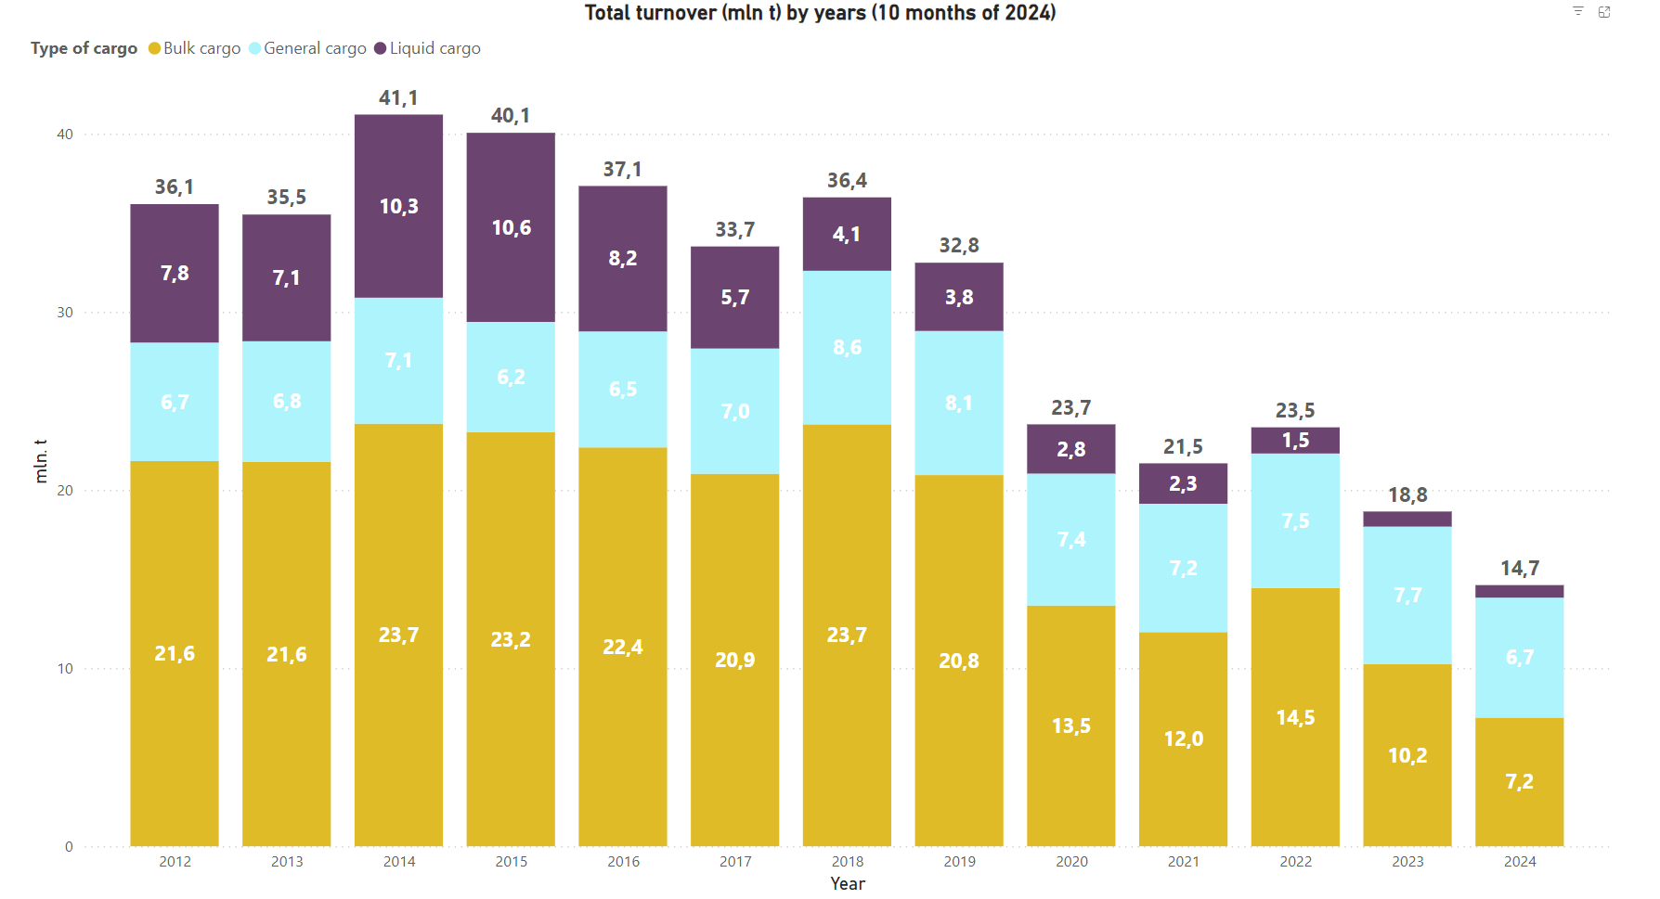

**Fig. 1.** Cargo turnover in 2024 from Riga Port

In terms of vessel traffic, Riga has seen a decline from over 3,500 ship calls in 2021 to approximately 2,900 in 2024, reflecting the reduced volume of bulk freight. However, initiatives to attract new trade flows, including partnerships with Central Asian countries and expanded logistics services, have helped mitigate the full impact of lost Russian cargo.

### Port of Tallinn

The Port of Tallinn experienced significant changes in cargo and ship volumes due to the sanctions imposed on Russian and Belarusian goods, alongside broader economic challenges. In 2023, cargo volumes totaled approximately 13 million tonnes, marking a 29% decline [44][47] (5 million tonnes less) compared to the previous year. This was primarily driven by reduced liquid bulk cargo originating from Russia and economic slowdowns across Estonia and its trade partners. Vessel traffic remained relatively stable, with a slight 1.5% decrease to 7,026 ship calls during the year​

For 2024, preliminary data indicates a continued focus on adapting to market shifts and sustaining cargo operations despite reduced reliance on sanctioned regions. By Q1 2024, cargo operations showed stabilization, especially in container handling, which grew by 16.3% year-on-year [45], reflecting improved trade flows with non-Russian markets​

When comparing 2021 to the present, the shift away from Russian-linked cargo has been the primary driver of the decline. In 2021, the port handled significantly higher volumes of transit cargo [46], supported by Estonia's role as a regional trade hub. The port's diversification efforts are now evident in the growth of alternative sectors such as containerized and island ferry cargo, which offset some losses from sanctions​

Numerically, the port's cargo handling in 2023 (13 million tonnes) [47] contrasts starkly with its pre-war performance in 2021 (22.4 million tonnes) [46], where annual figures were substantially higher. Similarly, ship call volumes reflect a degree of resilience, with minor reductions that highlight effective operational adjustments amidst geopolitical disruptions.

### Port of Klaipeda

In 2021, the port handled 47.79 million tons of cargo and saw 6,540 ships dock [6][8]. The war in 2022 significantly disrupted transit routes, particularly with the loss of Belarusian bulk fertilizers, which were a major cargo type. This led to a steep drop in cargo throughput, which declined by 21% in 2022 to 36.1 million tons [32], marking the lowest level since 2013 (Fig. 2). The number of ships calling at the port also decreased by 14.4%, to 5,605 ships [31].

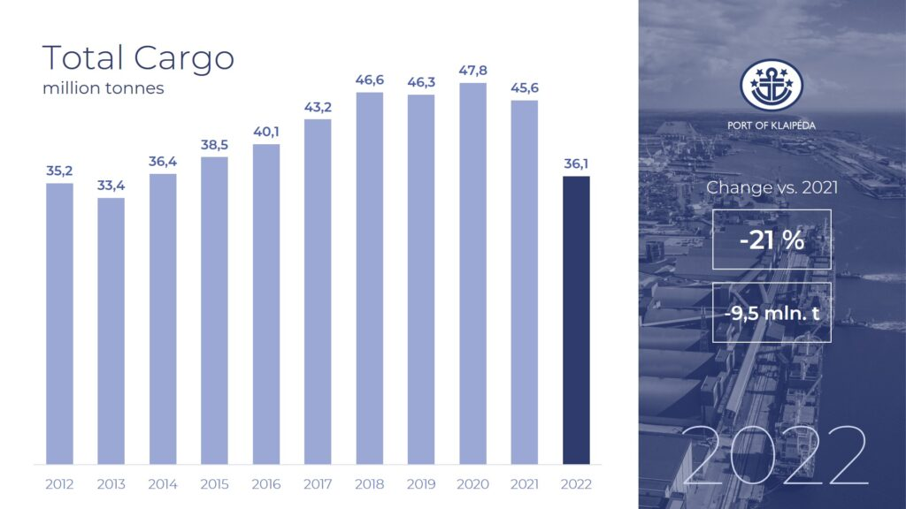

**Fig. 2.** Port of Klaipeda 2022 vs 2021 turnover

By 2024, the port's performance reflects a period of stabilization [33], with an approximate cargo throughput of 35 million tons [8][37]. This figure, while still below 2021 levels, indicates only a marginal decline since 2022, showcasing Klaipėda's strategic response to the crisis. Investments in infrastructure, including facilities for LNG products and container handling, have helped offset the losses in other cargo types (Fig. 3). Meanwhile, the number of ships docking at the port in 2024 is estimated at around 5,700 [37], representing a slight recovery compared to the war-impacted 2022 figures.

Lithuania's maritime sector is crucial for its economy, mainly because of the Port of Klaipėda, one of the largest ports in the Baltic States [32]. This shows how vital it is as a transit hub for regional trade and energy supplies, stressing the need for advanced maritime monitoring technologies to support its operations.

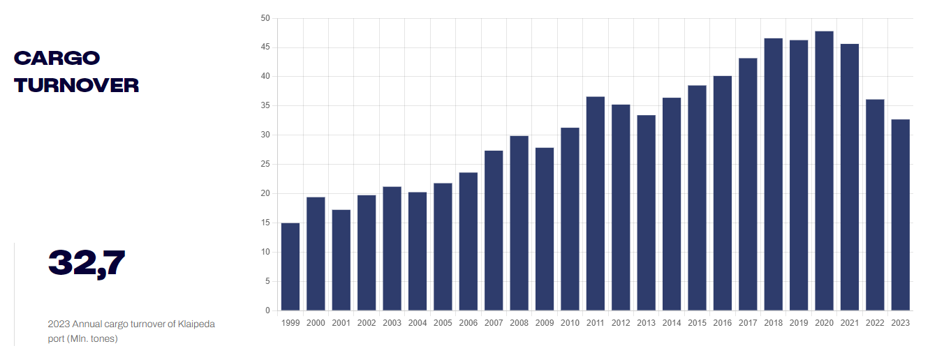

**Fig. 3.** Port of Klaipeda 2023 turnover

Lithuania's marine industry benefits from a strong environment for innovation [5]. The Marine Valley initiative in Klaipeda truly shows this engagement by bringing together science, education, and business to promote high-tech developments and research [4]. Key institutions include Klaipeda University and the Klaipeda Science and Technology Park. Lithuania have invested much to upgrade infrastructure, such as developing modern, biggest in Baltic states park [1][2], of renewable energy and aquaculture laboratories. These facilities are designed to foster cutting-edge research and provide a foundation for my work.

Additionally, the EU-CONEXUS “Research for Society” (RFS) project [7] – a collaboration of European coastal universities – shows a strong commitment to innovation in marine research. The RFS supports multi-disciplinal studies and innovations to address social challenges, including advancements in marine technology and environmental sustainability. Lithuania’s participation in projects like EU-CONEXUS creates a favorable environment for applying my findings to improve marine tracking and maritime safety.

Lithuania's focus on green energy [3] and technology supports a positive environment for advancing marine research [4][5]. Investments in marine research and the establishment of tech valleys align well with my goal of optimizing satellite-based detection systems. My aim is to provide practical tools for monitoring maritime traffic and increasing safety in the Baltic Sea region.

## Analysis of Existing Satellite Imagery Database

### Previous work

The Kaggle dataset titled “Ships in Satellite Imagery” (“SSI”) was discovered during investigation for foundation and it has been incredibly helpful for this thesis.

This collection features various satellite images specifically designed to spot ships on the water, which is crucial for training machine learning models for ship detection. It mainly focuses on images taken from the San Francisco Bay area [9].

One important aspect of this dataset is that it comes in two formats: full-sized satellite images (see Fig. 4) and smaller ones measuring 80x80 pixels (see Fig. 5) [9].

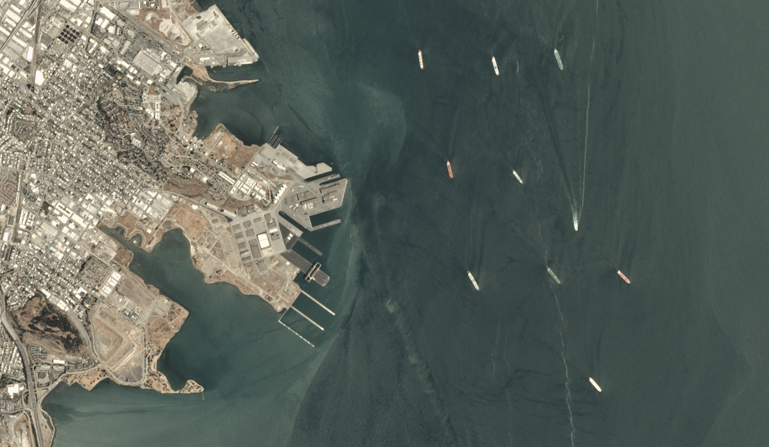

**Fig. 4.** Example of the scenery from „SSI“ dataset

The smaller images are especially advantageous for image classification tasks, as they make it easier for AI models to identify ship-like patterns.

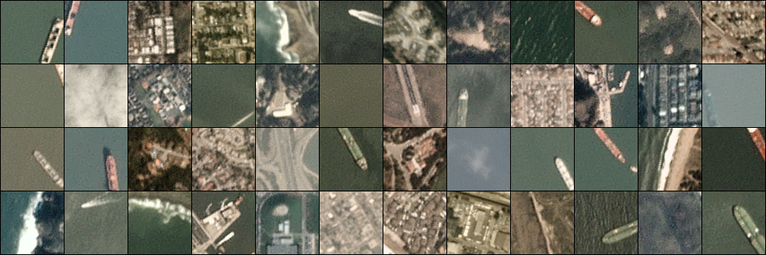

**Fig. 5.** Example of smaller tiles from „SSI“ dataset

While this dataset pertains to a different geographic area than this research, which centers on the Baltic Sea near Lithuania, it provides valuable lessons on how to structure and utilize labeled ship data effectively for machine learning applications.

However, one significant drawback of this dataset is its dependence on commercial satellite imagery [9]. Although the images are of high quality and resolution, they are not freely accessible or open-source, which creates challenges for students and academic researchers.

This work focuses on ship detection along Lithuania's coastline in the Baltic Sea, so we need to rely on public datasets like those offered by the Copernicus program. This strategy not only helps to navigate access limitations but also requires to modify methodologies from existing studies, such as this Kaggle dataset, to fit our local conditions and the characteristics of the freely available imagery we work with.

### Analysis of Existing Image Recognition Systems

Finding analogous projects was crucial to guide the methodology and enhance the approach. This particular notebook, **Boat Detection in Satellite Images Using Keras (BDSK)**, became a valuable resource because it demonstrates the end-to-end process of setting up a machine learning pipeline for ship detection.

The notebook’s strategies, are directly applicable. While the notebook uses commercial satellite imagery, these methods may be adapted for open-source Copernicus data to fit our regional context along the Baltic coast. This adaptation will address the challenges of open-source data while benefiting from the robust approach already presented here.

**The Data Preparation phase** begins with the essential task of importing key libraries, notably Pandas for managing data frames and NumPy for conducting numerical computations [10].

Following this, the code systematically loads image files from designated directories, organizing them into structured arrays [24] that are essential for the subsequent training of the neural network. In this stage, the images are resized to a standard dimension of 80x80 pixels, ensuring uniformity in the input shape required for model training.

To enhance the performance of the model, the pixel values of the images are normalized [10]; this is achieved by dividing each pixel value by 255, which scales the data to a range between 0 and 1[25].

This normalization process is crucial as it fosters more efficient training, particularly when utilizing gradient-based optimization techniques. Furthermore, the dataset is divided into training and testing subsets, utilizing an 80-20 split [10][24].

The **Model Building** block of the notebook is a critical foundation for designing a Convolutional Neural Network (CNN) tailored for binary classification of ships in satellite images. The model structure consists of 19 layers (Fig. 6.), including three convolutional layers that extract key features from the 80x80 grayscale inputs. All convolution activated using ReLU to effectively capture spatial relationships.

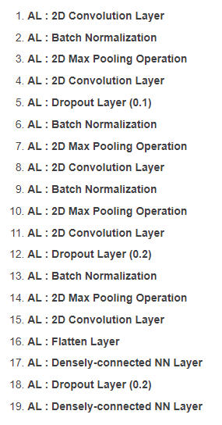

**Fig. 6.** Structure of the previously applied CNN model

To manage overfitting and maintain model performance, max-pooling layers are incorporated after each convolutional layer to downsample and preserve patterns. Dropout layers follow, with 0.1 and 0.2 rates strategically reducing overfitting risks. A flatten layer prepares the output for the fully connected dense layer, which has 128 units with ReLU activation. Finally, a dropout layer is used before the output layer, which uses sigmoid activation to handle binary classification.

## Investigation of Satellite Imagery Sources

Copernicus Data Space System (Fig. 7) is the European Union's flagship Earth observation initiative, designed to provide valuable information services to citizens and organizations across the EU [11]. It utilizes a combination of satellite Earth observation and in-situ (non-space) data to monitor and understand our planet and its environment.

The data produced by Copernicus is of such high quality and relevance that it was transformative for the Earth Observation industry, and its free and open data policy is the cornerstone of the program [12].

The goal of the Copernicus program is to make Earth observation-based solutions accessible to all, and to leverage the power of this data to drive positive change and preserve our planet [11].

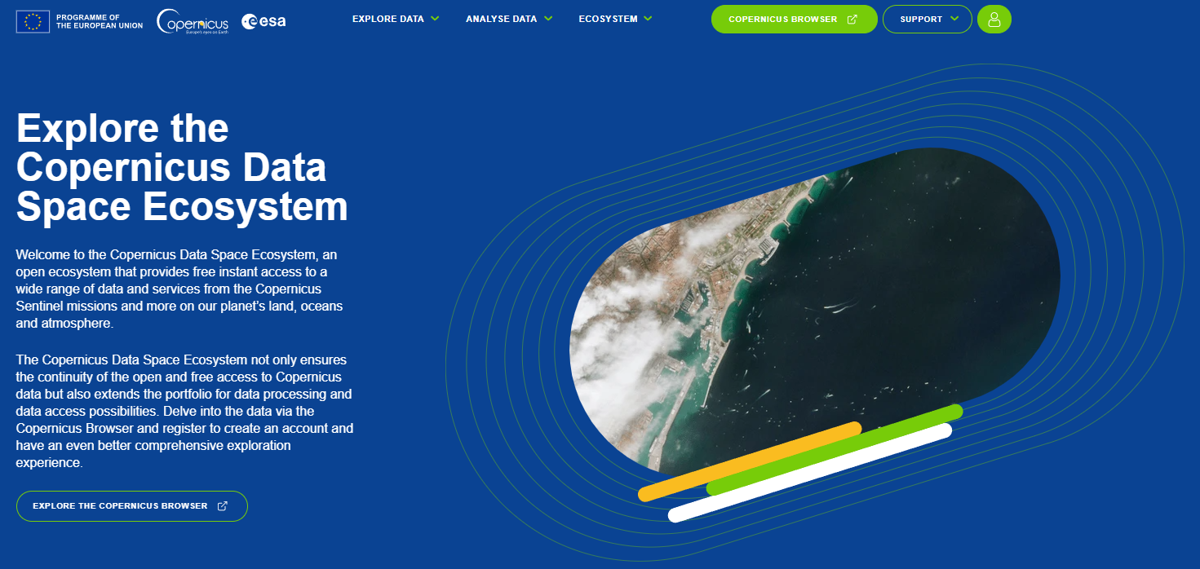

**Fig. 7.** Main page of "Copernicus" website

Central to Copernicus are the Sentinel satellites, each of which is uniquely equipped to capture high-resolution images and environmental data across different domains. The Sentinel satellites in the Copernicus program are each designed with specific observation tasks in mind. For instance, Sentinel-1 uses radar imaging, which allows it to capture images in all weather conditions and even at night. This makes it especially useful for ongoing monitoring over areas like oceans and coastlines [11]. Thanks to this technology, Copernicus can provide consistent updates and a steady flow of data, supporting both real-time tracking and looking back at changes over time.

An essential feature of the Copernicus program is its commitment to open data access. All satellite data from Copernicus are freely available to the public, a policy that effectively democratizes access to high-quality Earth observation data. This open access approach has not only broadened the scope of research and applications within the scientific community but has also allowed researchers, governmental organizations, and commercial entities to develop innovative applications based on Copernicus data.

### Copernicus Dataspace Browser

The Copernicus Dataspace Browser (See Fig. 8) is an intuitive, web-based tool that helps users navigate and access the wide range of satellite imagery collected by the Copernicus program. It’s built to be user-friendly, so researchers, students, and even those new to satellite data can easily search for images based on location, date, or the specific satellite mission.

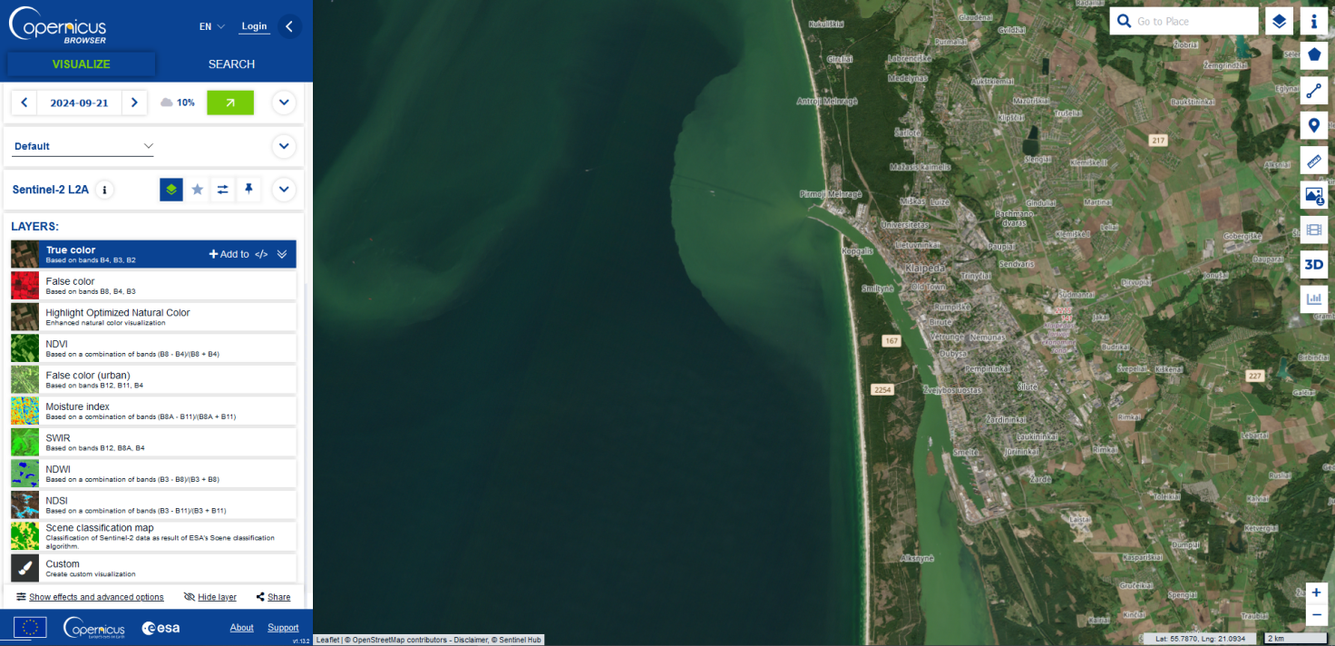

**Fig. 8.** Copernicus Dataspace Browser Interface

At the core of the interface is a map-based viewer that makes interacting with satellite data both intuitive and engaging [12]. You can easily zoom in on specific areas and get a closer look at what interests you most. The search options are also user-friendly, allowing you to narrow down your findings by location and date, so you can focus on the exact places and time periods you want to explore.

One of the great features of this browser is its variety of image layers [12]. You’ll find options like true color, which gives you a natural view of the landscape, as well as different spectral bands that can show things like vegetation and water quality (Fig. 9). The Copernicus Dataspace Browser enhances any research or analysis with these diverse image layers. You can switch between them to see how different conditions affect what you’re looking at. For example, false color images can help you spot areas with healthy vegetation, while infrared images can reveal heat patterns on the ground.

These layers are adjustable, which means you can tweak them to highlight different environmental details. Playing around with contrast and brightness can improve clarity, helping you pick out features that might otherwise blend into the background [12] – like the shapes of hills, the quality of lakes, or urban development in cities.

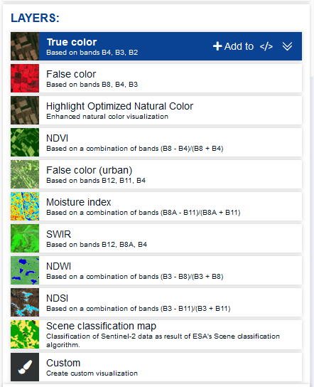

**Fig. 9.** Layers' settings in Copernicus browser

Another useful tool is the cloud coverage filter (Fig. 10), which helps clear up images by minimizing the effect of clouds. This is especially useful for getting a good look at the landscape [12]. Plus, there’s an interactive timeline feature that makes it simple to track changes over time, so you can see how an area has evolved from one date to another.

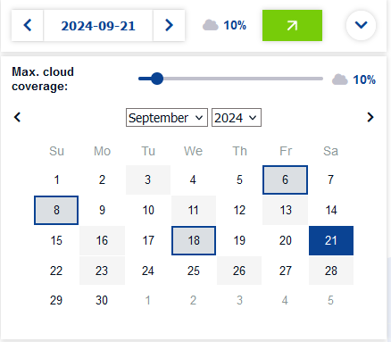

**Fig. 10.** Timeline and coverage filter

You also have access to a range of datasets, including those from Sentinel-2, tailored to your specific observational goals. After filtering the data, you can easily download images (see Fig. 11) for offline analysis, making it convenient to work with what you find.

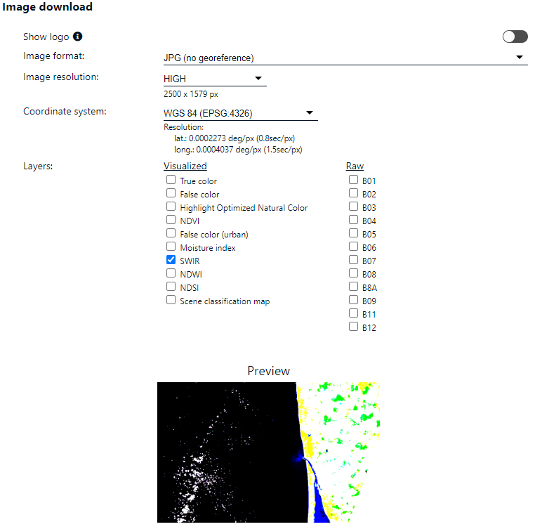

**Fig. 11.** Setting of download of desired data

### Data preprocessing used during data acquisition

During the work, the images were preprocessed even at the stage of the data acquisition. SWIR level was used and the gain and gamma of the downloaded images was increased (Fig. 12).

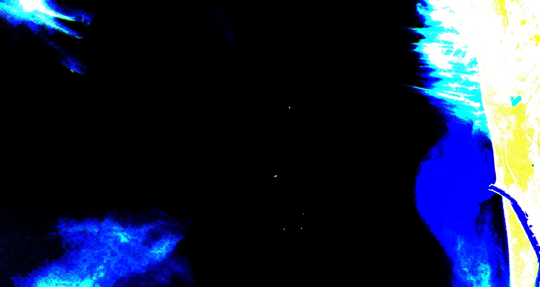

**Fig. 12.** Example of preprocessed and downloaded scenery

The SWIR (Shortwave Infrared) band is useful for giving a clearer picture of the environment. It helps to easily tell apart water, land, and vegetation, which is especially helpful when the weather isn’t great and things are a bit hazy [15].

A particularly valuable application of the SWIR band is in the detection of ships on water. By rendering water in a dark and making ships in bright white, this band creates a clear contrast that simplifies visual identification. This clarity is crucial for training AI models, as it enables them to recognize and learn the unique characteristics of ships against the contrasting background of the water.

To further improve the visibility of ships, specific adjustments need to be done to the data. For instance, the gain needs to be set high (16.2) to increase the brightness of the ships, and gamma correction at a level of 10 should be applied to enhance the overall contrast. This ensures that the ships are prominently displayed, reducing visual noise in the data and enhancing the accuracy of AI detection.

## Study of Machine Learning Techniques

During research, various machine learning frameworks were analyzed to select the most suitable options for the project. The primary objective [24] was to identify frameworks that not only delivered high performance, but also included essential tools for efficient data processing [25], model training and hyperparameter tuning [26]. Guided by these intentions, the frameworks that best meet the specific needs of working with satellite imagery were chosen, which are suitable by functionality and ease of implementation

Tensorflow is a robust open-source platform widely used for machine learning and deep learning. It provides comprehensive tools for building and training neural networks, essential for image-based tasks such as object detection [22][18]. It executes efficiently, even on large datasets, so it offers an optimal blend of flexibility and scalability, which is beneficial when processing extensive satellite imagery data.

Keras, integrated within TensorFlow, is very simple and user-friendly. It simplifies the design of complex neural networks by providing modular layers and easy to use APIs, allowing researchers to iterate quickly over various model architectures [23][22]. Keras is very valuable for prototypes and rapid experiments, making it easier to fine-tune models and experiment with hyperparameters to maximize detection performance [18].

For data manipulation, Pandas is indispensable for handling and transforming large datasets. It allows for efficient reading, cleaning, and structuring of satellite image metadata [20][25], which is crucial for organizing input data and preparing it for model training. NumPy complements this by enabling fast numerical computations [20][19], which are fundamental in managing image data arrays and performing matrix operations that underlie the functioning of CNNs.

For data visualization, Matplotlib offers extensive capabilities to display trends and patterns within the data and monitor model performance metrics [21] like accuracy and loss.

### Hyperparameters optimization techniques

Grid Search is one of the most straightforward approaches for hyperparameter optimization. It involves systematically evaluating all possible combinations of hyperparameter values within a predefined search space [26]. Although this method guarantees that the best configuration within the grid is found, it can be highly resource-intensive, especially when dealing with multiple parameters or large ranges of values. For smaller or simpler tasks, it remains a reliable baseline technique.

Random Search takes a different approach by sampling hyperparameters randomly within defined ranges. Studies, such as the work by Bergstra and Bengio [27], have shown that this method can outperform Grid Search in scenarios with high-dimensional spaces. This happens because Random Search explores a wider variety of configurations without being constrained by the rigid structure of a grid.

Bayesian Optimization uses probabilistic models to predict the performance of hyperparameter configurations based on prior evaluations[28]. This method balances exploration of new areas with exploitation of promising regions in the hyperparameter space. Scikit-Optimize and Meta’s Ax platform[29] are one the most popular and biggest implementers of Bayesian Optimization effectively, making it suitable for computationally expensive tasks.

Optuna [30] is a cutting-edge optimization library designed for modern machine learning needs. It features automated hyperparameter tuning using algorithms such as Tree-structured Parzen Estimators (TPE) [30]. Optuna integrates with major machine learning frameworks like Tensorflow, PyTorch, and Scikit-learn, offering visualization tools to analyze optimization trials, which is particularly valuable for projects involving complex datasets like satellite imagery.

### Evaluation of machine learning models

Evaluating the quality of object detection in satellite images involves several key metrics [48]. These metrics, usually derived from the Confusion Matrix, like Precision, Recall, F1 score and mAP, are directly related to the Accuracy and Generalization capabilities of a Convolutional Neural Network (CNN) model implemented in TensorFlow [49].

*Accuracy* is a generalized measure of how often the model correctly identifies objects. It is calculated as the number of correct predictions divided by the total number of predictions. High accuracy indicates that the model is performing well on the training data.

*Generalization* refers to the model's ability to perform well on new, unseen data. A model that generalizes well will maintain high accuracy even when tested on data that was not a part of the training set. Generalization is crucial for real-world applications where the model encounters diverse and unpredictable scenarios.

In binary classification, the metrics typically focus on classifying each data point (image tile) into one of two classes. The confusion matrix and derived metrics, like precision, recall, F1 score, and accuracy are straightforward since there is only one decision to make for each data point (image or image tile). Meanwhile, it should be noted that object detection is usually a more complex process, as it involves both classification and localization (i.e. determining where the object is located in the image). Besides classifying an object, the model also needs to localize it with a bounding box. This requires evaluation metrics like Intersection over Union (IoU) to measure how well the predicted boxes match the ground truth boxes. The relationship between the model's performance and the main metrics derived from the Confusion Matrix is as follows.

*Precision*, *Recall* and *F1*. High *precision* means the model makes fewer false positive errors, while high *recall* means it detects most of the actual positives. Balancing these metrics (using the *F1 score*) ensures the model is both accurate and comprehensive in its detections. The *mAP* metric provides a comprehensive evaluation by averaging precision across different recall levels. A high *mAP* score indicates that the model performs well across various thresholds, reflecting both accuracy and robustness.

In TensorFlow, these metrics are often used during training and validation to monitor and improve the model's performance. Techniques like cross-validation, data augmentation, and regularization are employed to enhance generalization and ensure the model performs well on unseen data.

The formulas for the metrics reviewed above are as follows:

**Accuracy:**

$Accuracy= \frac{TP+TN}{TP+FP+TN+FN}$ (1)

**Precision:**

$Precision= \frac{TP}{TP+FP}$ (2)

**Recall:**

$Recall= \frac{TP}{TP+FN}$ (3)

**F1-Score:**

$F1=2∙\frac{Precision∙Recall}{Precision+Recall}$ (4)

## Adaptation of Project Focus

The original vision for this project was quite ambitious – to develop an advanced system that not only detects ships in satellite images, but also classifies them into various types, such as cargo vessels, tankers, roro ships, yachts and smaller boats.

This additional functionality aimed to greatly improve maritime monitoring by enhancing security measures simplifying the identification of different types of sea traffic and offering a more comprehensive tool for maritime authorities and operators.

The classification feature was intended to promote safer and more efficient maritime operations. Being able to quickly identify the type of vessel could help in ensuring compliance with maritime traffic regulations, support emergency responses or facilitate more efficient port management by predicting the logistical requirements of different ships.

While investigating potential sources of satellite imagery to support this project, several advanced systems that provide high resolution data for maritime applications was discovered. Some prominent services included platforms like Airbus Defence and Space's Pliades [16] and Maxar's WorldView [17] which are well-known for their commercial high-quality satellite imagery coverage in Europe. Unfortunately, these platforms require significant financial investment for access, posing a substantial difficulty for developing a comprehensive and detailed ship classification system.

Facing these limitations, the Copernicus DataSpace program [11][12] is ultimate. Copernicus stands out for its wide data availability and features that have already supported numerous environmental and maritime research projects, but despite these strengths, the Copernicus data lacks the necessary scale (Fig. 13) and resolution of commercial providers, falling short of the detail required for accurate ship classification. This limitation ultimately influenced the decision to shift the project’s focus, prioritizing feasible goals within the constraints of the available data.

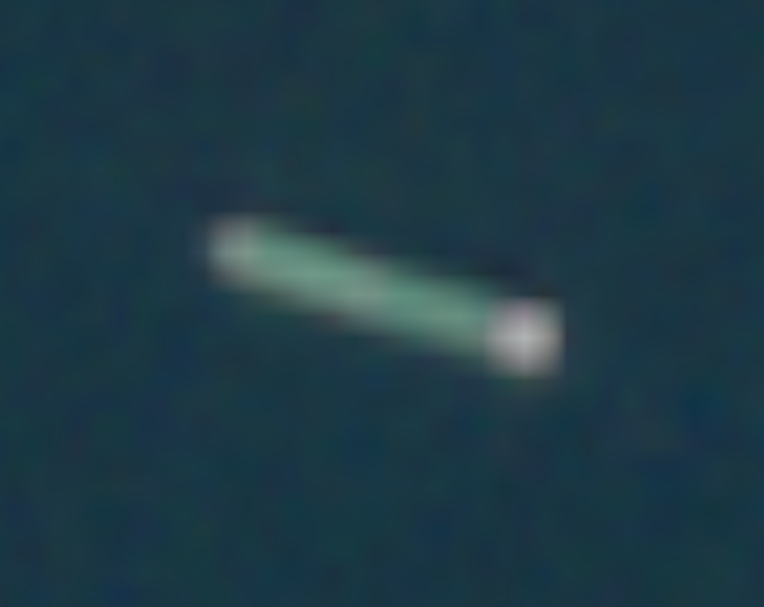

**Fig. 13.** Ship at maximum scale using Copenicus DataSpace Browser

Given the limitations in accessing high-resolution commercial satellite imagery, the initial plan to develop a system capable of classifying different types of ships would not be feasible. The detailed data required for such accurate classifications were not accessible through free or open-source platforms. Consequently, it was decided to concentrate on a more practical and achievable goal using the Copernicus imagery. This involved creating a robust and efficient system [24] for detecting the mere presence of ships within satellite images, rather than distinguishing between different vessel types. This adjustment ensures that this project remains relevant and beneficial, contributing valuable insights for maritime monitoring along the Lithuanian coast.

## Conclusion of the section

During analysis, several critical challenges related to maritime traffic and the detection of ships via satellite imagery were obtained. The impact of the geopolitical changes was highlighted, greatly influencing logistics and cargo handling in the region. One of the biggest concerns is the accessibility and quality of satellite imagery for a detailed classification of ships. While there are reliable sources of data, they often fall short in completeness, making accurate analysis difficult.

Also, the problem of optimizing machine learning models for ship detection was raised. The focus is on improving both the accuracy and computational efficiency of these systems. To avoid the limitations imposed by the characteristics of available images on data processing and algorithm performance, various methods for optimizing the model hyperparameters were also investigated.

# System Design and Model Framing

## Training Data Overview

### Features of initial data

The initial dataset consists of six high-resolution satellite imagery scenes, each with a resolution of 2500x1328 pixels. These scenes were captured on the period from September 2024 to the end of October 2024, focusing on the port of Klaipeda and its surrounding waters.

This timeframe aligns with maritime activity typical of late summer and early autumn, providing a representative and recent sample of shipping patterns in this region. The overall cloud coverage during this period was relatively low, around 10%, which ensures clear visibility of the water and ships essential for accurate detection.

The geographic extent of the dataset spans from latitude 55.84 and longitude 20.47 to latitude 55.66 and longitude 21.13, with a scale of 1:133,333 to balance the area and detalization, encompassing approximately 824 square kilometers. This area includes both the busy port of Klaipeda and the adjacent waters, representing a diverse range of maritime scenarios.

### Choice of Dataset type

Supervised learning is a machine learning paradigm where a model is trained using labeled data, where each input is paired with a corresponding output. This approach relies on annotated datasets, serving as a reference point during the training process, enabling the model to minimize errors between its predictions and the provided labels. In the case of ship detection from satellite imagery, supervised learning stands out as the most suitable method for several compelling reasons.

The primary advantage of supervised learning lies in its ability to tackle well-defined tasks like binary classification. Ship detection involves determining whether a satellite image contains a ship or not, making it a straightforward binary classification problem. The presence of explicit labels, such as ‘ship’ or ‘no_ship,’ allows the model to understand the task clearly. This structured learning process ensures that the model effectively distinguishes between the two categories, leveraging the labeled data to learn meaningful patterns.

By splitting the dataset into training and testing subsets, the approach ensures that the model not only learns from the data but also generalizes well to unseen samples. The ability to measure accuracy and precision provides a clear understanding of how well the model performs and facilitates iterative improvements.

Supervised learning also offers precise control over the training process. Loss functions and evaluation metrics provide immediate feedback during training, enabling the identification and resolution of issues such as class imbalances or underfitting. This level of control is particularly beneficial for tasks like ship detection, where the challenge often lies in distinguishing small ships against diverse backgrounds such as open water or coastal regions.

In this project, the focus is on using Convolutional Neural Networks (CNNs), which excel at capturing spatial hierarchies in image data. The inherent structure of supervised learning allows CNNs to optimize their performance by leveraging labeled examples, leading to a model that can accurately identify and classify ships based on their unique characteristics.

### Transformation of dataset imagery

The transformation of the initial satellite sceneries into a structured dataset suitable for machine learning required a few steps.

This process began with dividing the original scenery into smaller, manageable image tiles of 80x80 pixels (see Fig. 14). By fragmenting the larger sceneries, the dataset retained essential features, enabling a focused analysis on relevant regions, particularly those containing ships.

To achieve this fragmentation, a custom Python script was employed. Using the PIL library, the script iterated over each scenery image, systematically cropping them into 80x80 tiles. Each tile was then saved with a unique identifier in a designated output folder. The functionality of this script ensured that no region of the scenery was overlooked, as it covered the entirety of each image in a grid-like manner.

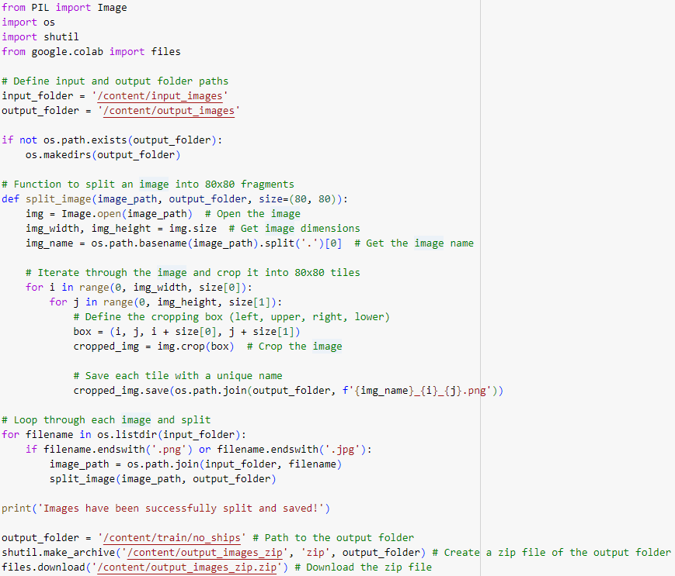

**Fig. 14.** Process of splitting initial scenery

Once the images were split into smaller tiles, the next phase involved manually sorting these fragments into two distinct categories: those containing ships and those without ships. This manual sorting was performed meticulously to ensure the highest possible accuracy in distinguishing between the two classes. Images identified as containing ships were placed into a directory labeled as *ships*, while the remaining images were stored in a directory labeled as *no_ships*.

After completing the sorting process, it was essential to systematically label the images. A CSV file was generated to associate each image with its respective label (Fig. 15). The labels were initially numeric, with 1 assigned to images containing ships and 0 to those without.

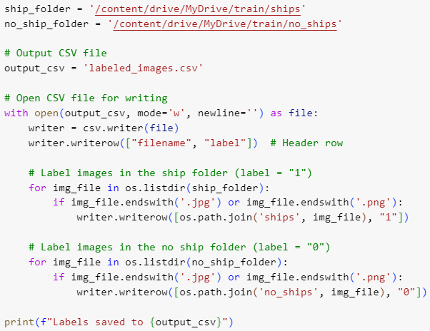

**Fig. 15.** Process of making csv dictionary of labels

The numeric labels in the CSV file then were converted to more descriptive string labels, with 1 replaced by 'ship' and 0 replaced by 'no_ship' (Fig. 16).

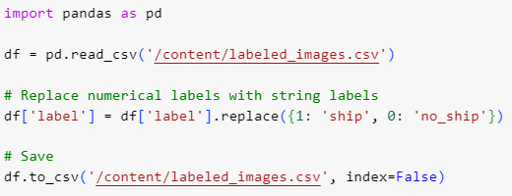

**Fig. 16.** Process of updating the labels

This conversion was performed to align the dataset with the format expected during the training phase (Fig. 17).

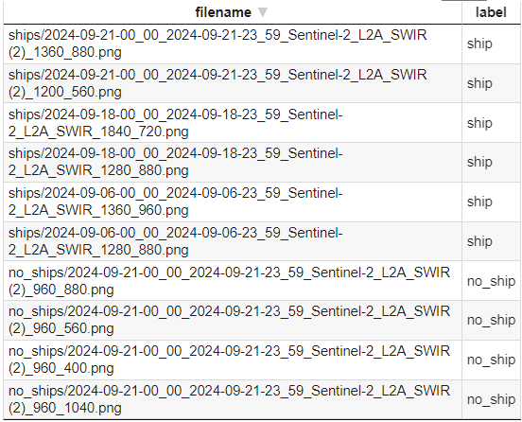

**Fig. 17.** Final look of labels dictionary

## System Architecture Design

The architecture of the machine learning system for ship detection in satellite imagery is structured to address the unique challenges. This system integrates several key components, each designed to optimize the performance of the detection model and ensure high accuracy and precision.

The first component of the system is the data processing pipeline. Satellite imagery from the Copernicus program serves as the primary input. Specialized filters are applied to negotiate challenges such as cloud cover or glare from water surfaces, ensuring that the input data is consistent and reliable. The data undergoes preprocessing steps, including image normalization, and augmentation techniques, such as rotations and flips, to enhance the model's robustness to environmental variability.

At the core of the system is the machine learning model, a convolutional neural network (CNN) chosen for its proven efficacy in image recognition tasks. The architecture of the CNN is designed to balance complexity and efficiency, incorporating convolutional layers for feature extraction, pooling layers to reduce spatial dimensions, and fully connected layers for classification. The model's hyperparameters – such as the learning rate, number of layers, and activation functions – are systematically optimized using grid search and cross-validation techniques to achieve the highest possible performance metrics.

The training process is carried out using Tensorflow, leveraging its capabilities for handling datasets. The RMSdrop optimizer is employed for its ability to converge quickly and effectively.

Finally, the deployment pipeline transforms the trained model into an operational tool for real-world applications. This involves integrating the model into a system that can process incoming satellite images in real-time, detect ships, and provide actionable insights.

## Model Implementation

The implementation of the ship detection model begins with setting up the computational environment. This stage ensures that all necessary tools and libraries are in place for seamless development and evaluation (see Fig. 18). In this project, essential libraries like TensorFlow and Keras are utilized for building and training the neural network. NumPy facilitates numerical computations, while Matplotlib provides tools for visualizing data. The os module manages file system operations, and the Python Imaging Library (PIL) handles image manipulation tasks.

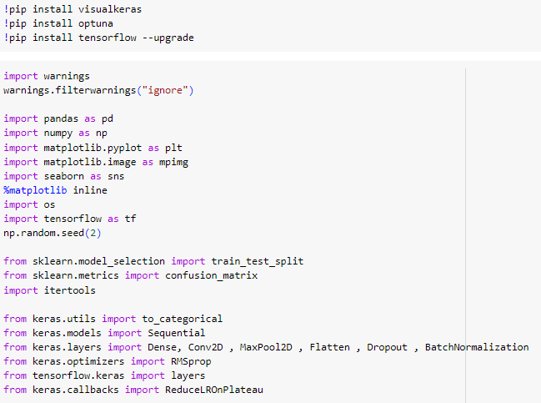

**Fig. 18.** Import of the necessary libraries

During next stage, the primary focus was on transforming raw satellite dataset into a format suitable for machine learning tasks, particularly ship detection.

The labeled dataset was structured into two subsets: an 80% training set and a 20% testing set (Fig. 19). This straightforward split ensured a sufficient amount of data for the model to learn patterns while reserving a portion for evaluating its performance during training.

The training set served as the primary source for the model to recognize and generalize features of the ship and non-ship classes, while the testing set was used to monitor the model's accuracy and loss, enabling adjustments to the training process if necessary.

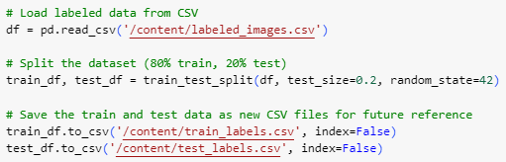

**Fig. 19**. Train/testing split of raw dataset

Normalization was a critical preprocessing step to scale pixel values to a range of 0 to 1. This adjustment mitigated potential issues with varying illumination or contrast, which are common in satellite images. By normalizing the dataset, the model's convergence during training was significantly improved. Grayscale conversion was applied to standardize input channels, as the model was designed for single-channel data.

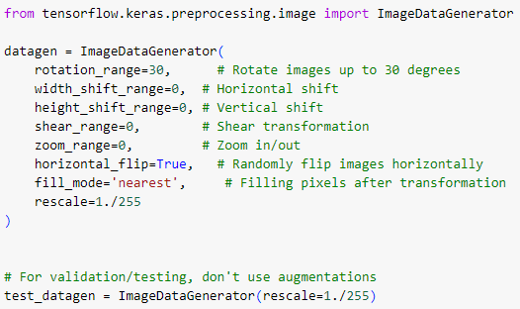

**Fig. 20.** Initializing augmentation techniques

Finally, augmentation techniques were incorporated to address class imbalances and enhance model generalization (Fig. 20). Augmentation operations included random rotations, flips, and zooms, which artificially expanded the dataset while preserving the original semantic properties of the images. These transformations were applied dynamically during the training phase using a data generator (see Fig. 21), allowing the model to encounter varied representations of ships.

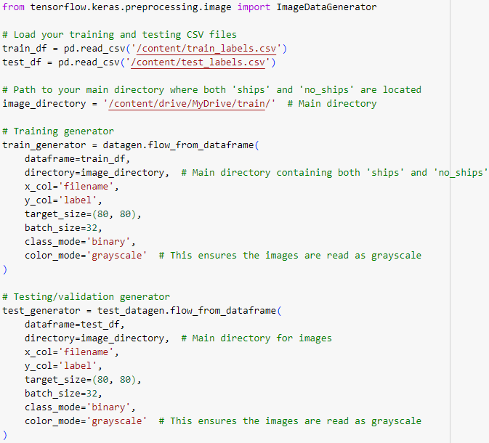

**Fig. 21.** Augmentation of training data

After the data preparation, model initializations follow. The convolutional neural network (CNN) architecture is implemented, specifically designed to handle the classification task of ship detection in satellite images. Leveraging the sequential API of Tensorflow's Keras library, the model was built to balance efficiency with the ability to capture meaningful features (see Fig. 22).

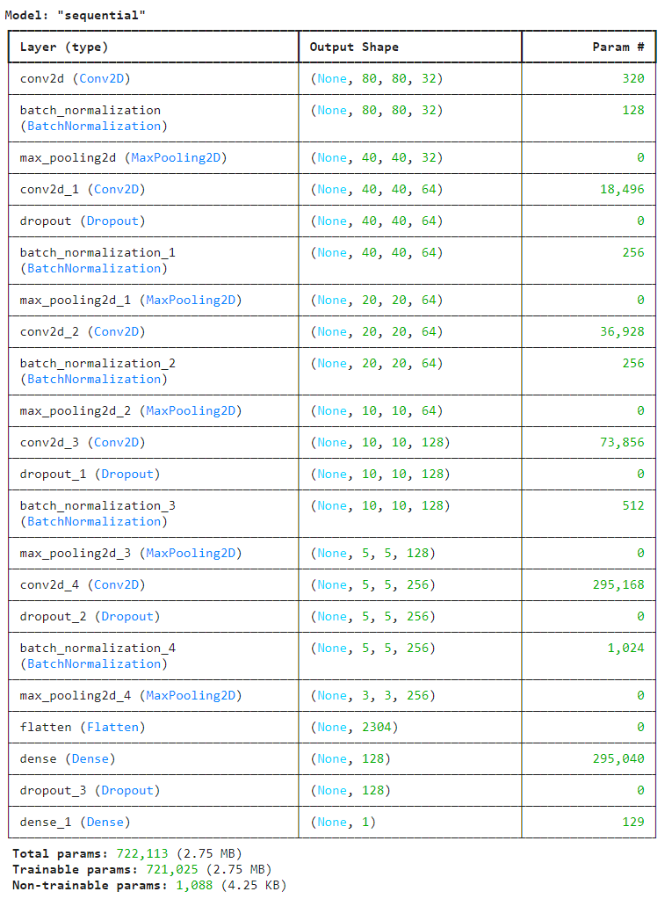

**Fig. 22.** Summary of the implemented model

The model begins with an initial Conv2D layer, comprising 32 filters with a kernel size of 3x3 followed by a Batch Normalization layer to stabilize and accelerate training. This first convolutional block identifies low-level patterns, such as edges and textures. A MaxPool2D layer is then applied with a 2x2 pooling size, effectively reducing the spatial dimensions while retaining the most relevant information.

The subsequent layers build progressively on this foundation. A second Conv2D layer, with 64 filters, is introduced to capture more complex features. This is augmented with Dropout (rate of 0.3) to reduce overfitting by randomly deactivating neurons during training, followed by another BatchNormalization and MaxPool2D operation. Similar structures are repeated with additional layers, increasing the filter count to 64, 128, and finally 256 filters in later blocks. The incremental increase in filters enables the model to recognize increasingly abstract patterns, critical for distinguishing ships from background noise.

Special care was given to regularization throughout the architecture. Dropout layers with rates ranging from 0.3 to 0.4 were strategically placed to ensure generalizability across unseen data. Batch normalization further contributed to the model's stability by normalizing the outputs of preceding layers, addressing potential issues such as internal covariate shifts.

The final layers of the network transition from feature extraction to classification. A Flatten layer transforms the 2D feature maps into a 1D vector, which is fed into a Dense layer with 128 units and a ReLU activation function. This dense layer condenses the high-dimensional features into a compact representation. A final Dense layer with a single unit and a sigmoid activation function was used for binary classification, outputting probabilities for the 'ship' or 'no_ship' categories.

To compile the model, the RMSprop optimizer was employed for its adaptive learning rate capabilities, paired with the binary cross-entropy loss function, aligning with the binary classification task. The model's performance is monitored using accuracy as the evaluation metric, providing a straightforward measure of classification success (Fig. 23).

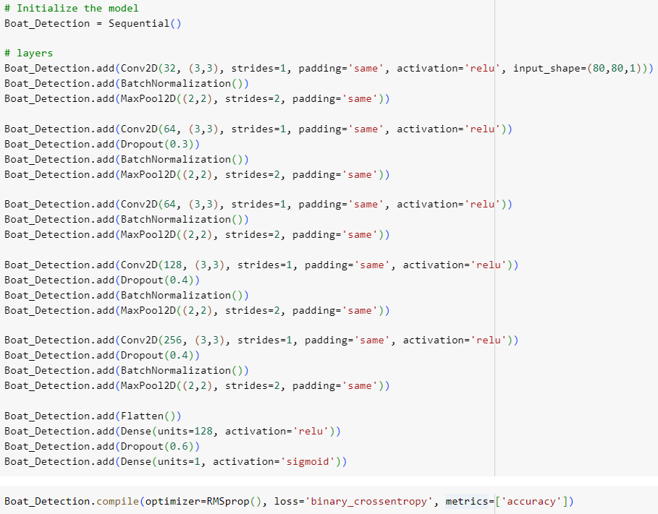

**Fig. 23.** Structure of the implemented model

The training setup ensures that the model is configured to handle the challenges of detecting ships. This stage focuses on addressing dataset imbalance, selecting callbacks for efficient training, and preparing the learning rate strategy.

To address the imbalance in the dataset, class weights were calculated using the class_weight module from scikit-learn (see Fig. 24). These weights assign appropriate importance to each class, ensuring the model does not disproportionately favor the majority class. For example, the computed weights for "ship" and "no ship" labels reflect their respective occurrences in the dataset, balancing their contributions during training.

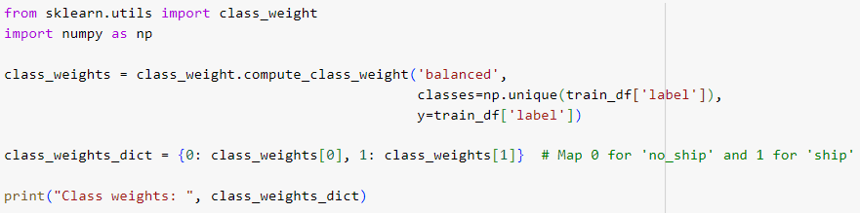

**Fig. 24.** Function to balance the dataset

To optimize the training process, two essential callbacks were incorporated: ReduceLROnPlateau and a learning rate scheduler. As seen at Fig. 25, The ReduceLROnPlateau callback reduces the learning rate by a factor of 0.5 if the testing loss does not improve over three consecutive epochs, preventing the model from stagnating at local minima.

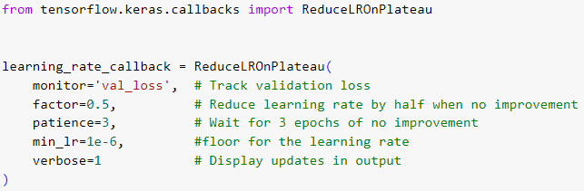

**Fig. 25.** Function to prevent overfitting

Alongside this, a custom learning rate scheduler was implemented to provide a dynamic learning rate adjustment throughout training. The scheduler includes a warmup phase during the first five epochs, gradually increasing the learning rate to stabilize initial convergence (Fig. 26). Following this, an exponential decay reduces the learning rate as training progresses, promoting fine-tuning in later stages.

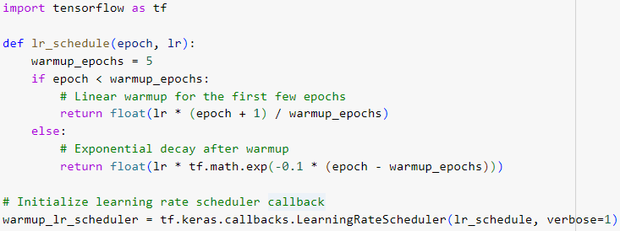

**Fig. 26.** Custom Learning rate scheduler

## Model Training and evaluation

The training process (Fig. 27), powered by the provided implementation, unfolded across ten epochs with a learning rate schedule that began at 2*10-4. The schedule utilized both the LearningRateScheduler and ReduceLROnPlateau callbacks, dynamically adjusting the learning rate to maintain optimization efficiency. These adjustments balance the pace of learning to avoid an overfitting.

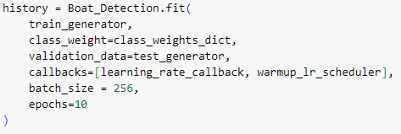

**Fig. 27.** Structure of training

From the outset, the training accuracy climbed from an initial 91.90% in the first epoch to 99.17% by the final epoch. Correspondingly, the training loss reduced significantly from 0.2920 to 0.0440. Testing performance showed a slower initial improvement but gained momentum later in training, with testing accuracy steadily climbing from 58.45% at the start to 91.69% by the end (see Fig. 29), while testing loss dropped from 1.5810 to 0.2099 (Fig. 28).

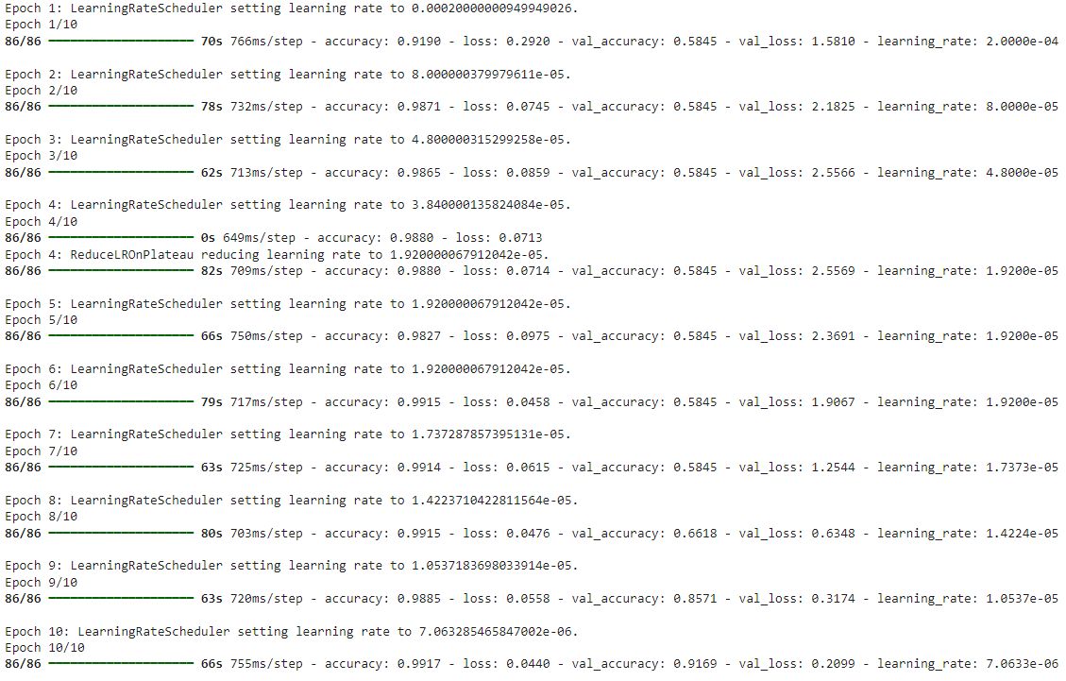

**Fig. 28**. Detailed epochs‘ results

The fine-tuned learning rate schedule was evident, with epoch-to-epoch reductions bringing it down to 7.06 * 10^-6 by the tenth epoch. This gradual decrement allowed the model to refine its weights more precisely as it approached convergence.

## Conclusion of the section

The initial ship detection system demonstrated notable limitations despite its ability to classify ships on satellite images. The dataset consisted of grayscale satellite images, where ships appeared as small, rice-shaped objects on a contrast backgrounds.

The model used a comparatively deep and complex convolutional neural network architecture, which, coupled with a modest dataset size, led to overfitting.

The results from this version of the code indicate several issues with the training and evaluation process, highlighting limitations in the model’s ability to generalize and the reliability of its reported performance. Initially, the model exhibited significant overfitting. In the first epoch, the training accuracy was 91.90%, while the testing accuracy was only 58.45%, showing a stark contrast. This gap suggests that the model learned to fit the training data well but failed to generalize to unseen testing samples. Overfitting continued in the early epochs, with the testing accuracy remaining stagnant at 58.45% until Epoch 7.

The testing accuracy only started improving significantly from Epoch 8 onward, eventually reaching 91.69% in the final epoch (Fig. 29). This late-stage improvement may have been influenced by the adjustments in learning rate through callbacks, but it raises concerns about the robustness of the initial training process. The model’s reliance on a single testing set (test_generator) further amplifies these concerns. A single testing set risks producing overly optimistic performance estimates if the test data is not representative of the overall dataset.

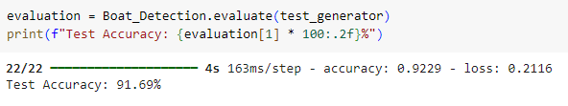

**Fig. 29.** Testing results

Testing loss trends add to the evidence of instability. During the early epochs, the testing loss was inconsistent and significantly higher than the training loss, reinforcing the conclusion that the model was struggling to generalize effectively during the initial training phase. Such instability often signals issues with the data distribution or the model's optimization strategy.

# Evaluation, Testing, and Optimization

## Hyperparameters’ tuning of the model

In order to confront issues raised with the initial code, manual tuning, enhancements and optimizations were executed.

### Introduction of cross-validation

Cross-validation is a statistical method used to evaluate and improve the performance of a machine learning model by systematically splitting the dataset into multiple subsets for training and testing. Cross-validation has been introduced to ensure the model's robustness and to address potential issues like overfitting or underfitting, which were not explicitly addressed in the initial code.

In the previous version of architecture, the dataset is split into training and testing sets using a single split, with 80% of the data used for training and 20% for testing. This approach evaluates the model's performance on a single test set, making it vulnerable to bias introduced by the specific split. For example, if the test set inadvertently contains a disproportionate number of challenging samples, the performance metrics may not generalize well to unseen data.

To address this issue, k-fold cross-validation was implemented (Fig. 30). Here, the dataset is divided into k subsets or "folds." The model is trained k times, each time using k-1 folds as the training set and the remaining fold as the testing set. This iterative process ensures that every data point is used for both training and testing, providing a more comprehensive evaluation of the model's performance.

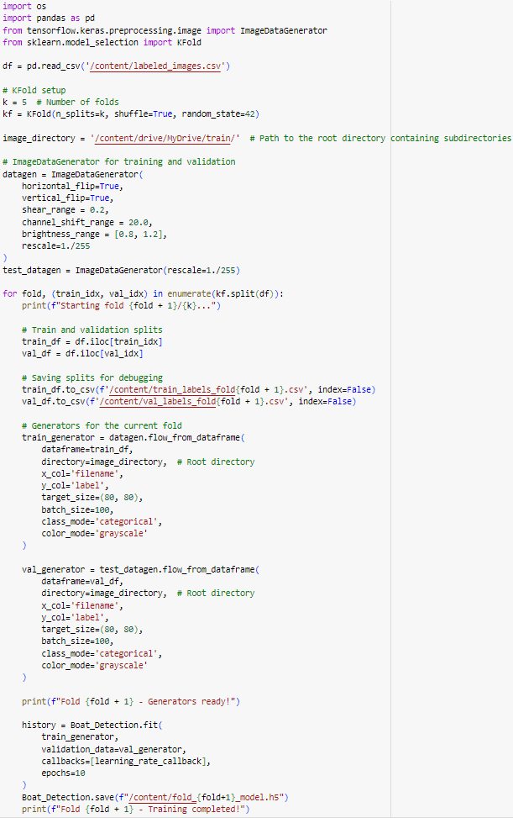

**Fig. 30.** Integration of K-fold cross-validation

### Changes in model structure

The main problem with initial model – is the strong overfitting problem. It decreased effectiveness of the model and reduces generalization to unseen data. The changes in the model architecture between the old and new versions reflect a shift in design focus.

The new model (Fig. 31) significantly reduces the number of convolutional layers from five to three, removes the 128 and 256-unit convolutional layers, and instead places emphasis on larger kernel sizes in the remaining layers. For example, the first convolutional layer now uses a 7x7 kernel, replacing the previous 3x3 kernel. Similarly, the second convolutional layer adopts a 5x5 kernel compared to the 3x3 kernel in the older version. Due to extreme simplicity of data images, more stripes were added. It was done to face the problem of catching surrounding noise of the images as the features of the ships, and therefore, to get more general features.

The dropout rates have been substantially increased throughout the architecture; for instance, the dropout rate in the second convolutional layer has been raised from 0.3 to 0.6. Additionally, a higher dropout rate of 0.7 is introduced in the third convolutional layer, compared to the previous 0.4 rate used in later layers of the old model (Fig. 31).

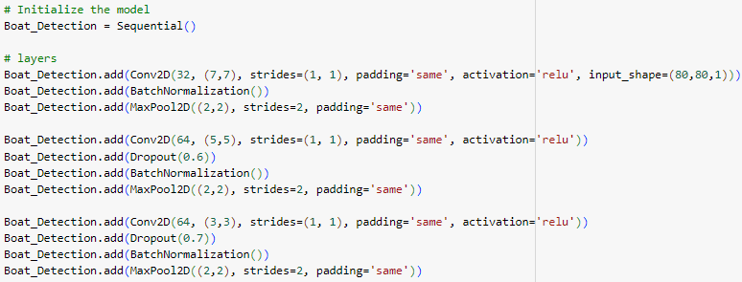

**Fig. 31.** Changes in entry and mid-layers

Another key difference lies in the dense layers. The new model reduces the dense layer units from 128 to 64 while introducing L2 regularization using regularizes l2(0.015) to help improve generalization. L2 regularization helps prevent overfitting by penalizing large weight values, encouraging the model to find simpler and more generalizable patterns. This makes the model more robust and better at handling diverse or noisy data, like in boat detection tasks. The dropout rate at this stage also increased from 0.6 to 0.8.

In terms of the output layer, the new model moves from a single-unit sigmoid-activated dense layer designed for binary classification to a two-unit softmax-activated layer, enabling categorical output (Fig. 32).

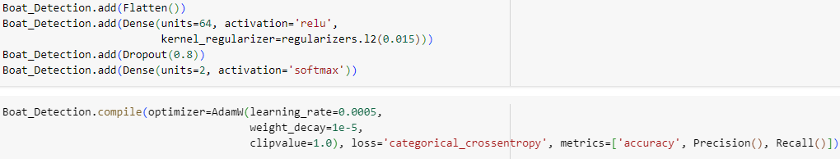

**Fig. 32.** End-layers‘ and model compilation configuration

These changes are implemented to solve the issue of possible training errors due to nature of labels. While categorical class may slow down training speed, is in not limited to label nature being only 0 and 1, representing ‘False’ and ‘True’ – ‘no_ship’ and ‘ship’. After moving to categorical classification, robustness of model was increased, because of new opportunities to have different label names, assigned to images, and, it opens the door for expanding the model features to classify the types of ships, in the future.

AdamW is an optimizer that improves training by combining the benefits of adaptive learning rates with weight decay, a form of regularization that helps prevent overfitting by discouraging overly large model weights. It's particularly effective for modern deep learning tasks because it balances efficient learning with good generalization. The clipvalue setting on the other hand, ensures training stability by capping the maximum size of gradients (Fig. 32). This prevents extreme updates to the model, which can happen due to noisy or overly large gradients, which could happen in the water due to depth or glance, etc.

### Training improvements

The comparison between the training results with and without cross-validation clearly demonstrates the advantages of the updated architecture. Without cross-validation, the model achieved relatively high training accuracy but struggled to generalize to unseen data. During the initial epochs, the training accuracy reached as high as 99.25%, but testing accuracy remained stagnant at 58.45%, as seen in the logs: "val_accuracy: 0.5845." This resulted in significant fluctuations in testing loss, with values like 2.8373 and 2.5490, pointing to overfitting and an inability to learn broader patterns beyond the training set. The model's reliance on a single testing split limited its exposure to data variability, making it prone to overfitting.

By introducing cross-validation, the model was exposed to multiple subsets of data during each epoch, enhancing its ability to generalize. The iterative process allowed the model to learn from various data splits, which significantly improved its performance on unseen data (Fig. 33). The testing accuracy gradually improved, achieving 92.13% by the eighth epoch ("val_accuracy: 0.9213") and peaking at 97.78% by the final epoch ("val_accuracy: 0.9778") (see Fig. 34.). Meanwhile, the testing loss showed a steady decrease, from 2.8373 to 0.0538, reflecting more consistent and stable improvements in generalization.

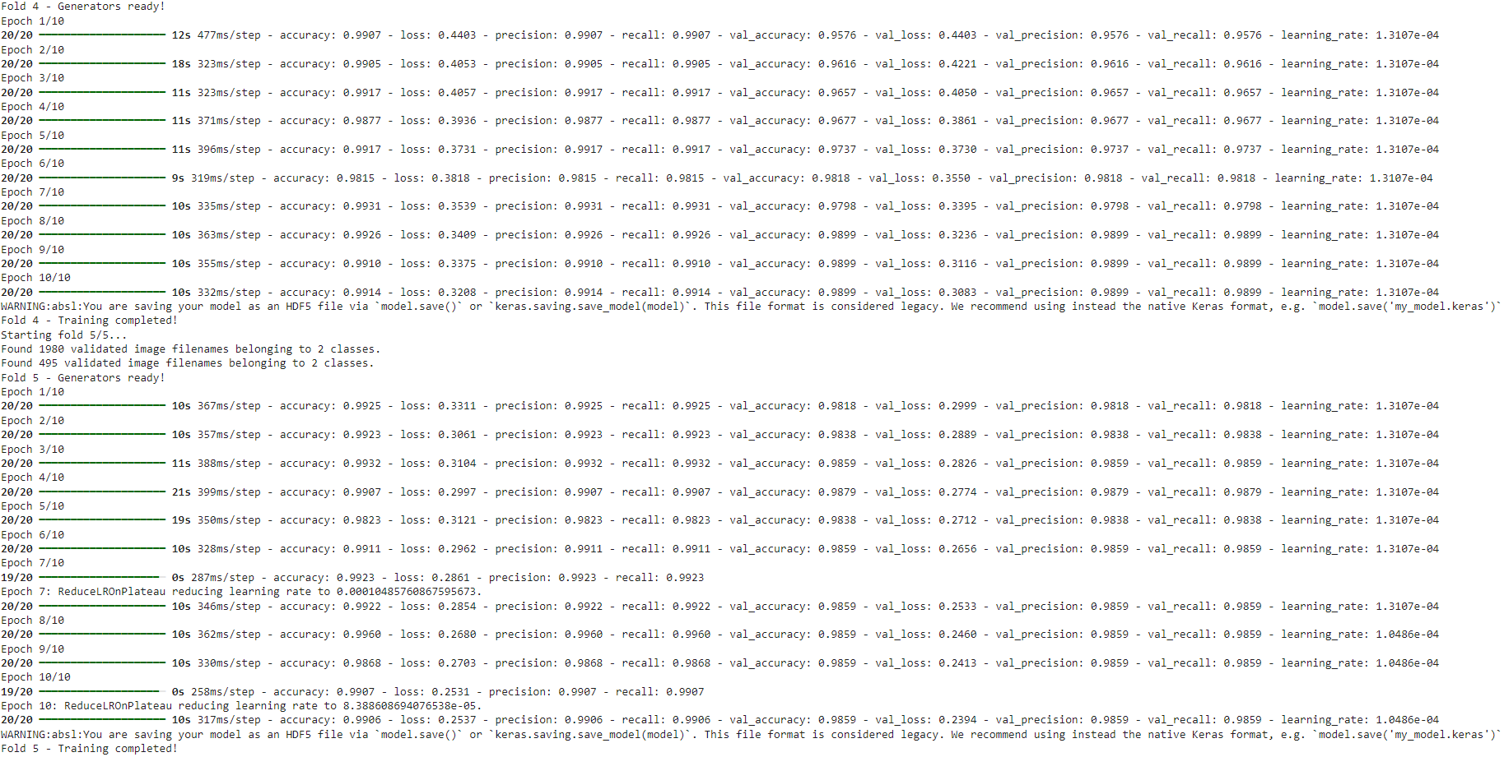

**Fig. 33.** A process of improved training

Cross-validation not only improved generalization but also facilitated more robust hyperparameter tuning. The model was exposed to diverse data subsets, leading to more reliable performance metrics and less susceptibility to bias from any single testing set. This made the training process more stable and adaptive to variations in environmental conditions.

Additionally, **testing precision and recall were tracked using built-in Keras‘ metrics functions**  throughout the training process, and both metrics demonstrated **consistent improvement** from 0.5845 to 0.9859.

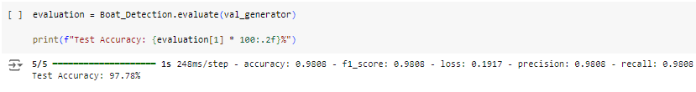

**Fig. 34**. Evaluation of improved model

## Analysis of impact of the hyperparameters

### Automated library

Keras Tuner is a powerful and user-friendly tool designed to optimize the hyperparameters of machine learning models, making it an essential resource for improving performance. Hyperparameters, such as the units per layer, activation functions, etc. significantly influence how well a model learns from data. Keras Tuner automates the search for optimal hyperparameter configurations through various strategies like random search, grid search, Bayesian optimization, and Hyperband. By systematically testing combinations of hyperparameters, Keras Tuner helps to identify settings that maximize a model's accuracy and efficiency, reducing the need for manual experimentation.

### Investigating performance dependency on the hyperparameters

A grid search methodology was utilized to systematically investigate the influence of key hyperparameters on the model's performance. Relevant value ranges were defined for parameters such as dropout rates and L2 regularizers to identify configurations that optimize test accuracy while mitigating overfitting. To facilitate a clear and precise analysis, the grid search was performed individually for each hyperparameter (Fig. 35).

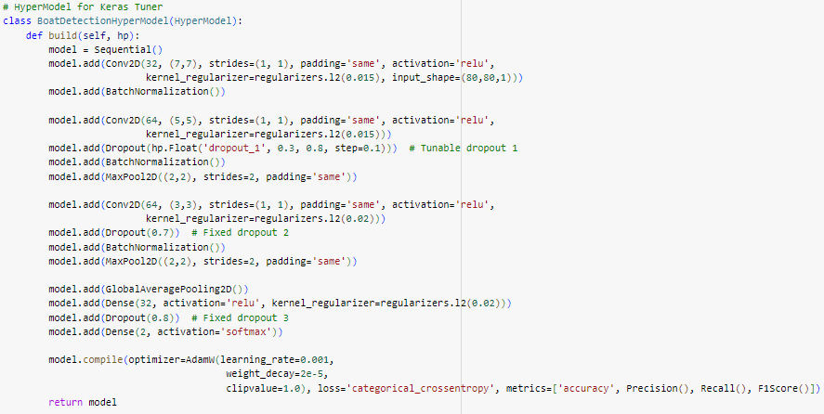

**Fig. 35.** Example of the model initialization in Keras Tuner

This approach ensured that the effects of each parameter were evaluated in isolation, enabling a more accurate understanding of its specific impact on the model's performance (Fig. 36). The results of these experiments provided detailed insights into the relationship between hyperparameter values and test accuracy, serving as a foundation for further fine-tuning and optimization.

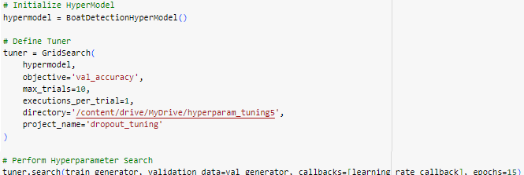

**Fig. 36.** Example of GridSearch

For each hyperparameter explored during the grid search, a corresponding plot (see Fig. 37 with Dropout1, Dropout2 and Dropout3 correspondingly) was generated to visualize its relationship with test accuracy. These visualizations provided a clear depiction of how varying values of a specific hyperparameter impacted the model's performance.

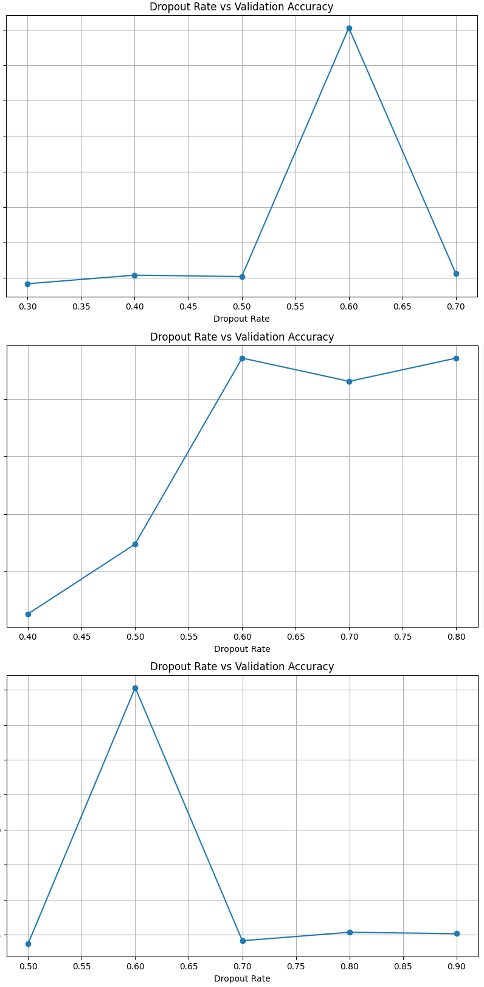

**Fig. 37.** Plots of conducted searches

## Workflow of the program

The program is designed to process satellite images for ship detection, following a streamlined and automated workflow. Users can utilize the program by uploading their image files into a predefined working directory, after which the program autonomously handles the subsequent tasks of splitting, processing, and prediction.

To begin, users are required to place their images in the specified upload directory (/content/1/). The program supports various image formats, including .png, .jpg, and .jpeg. Once the images are uploaded, the system identifies all compatible files within the directory and prepares them for processing.

Upon execution, each uploaded image is loaded in grayscale format for uniform processing. The program then divides the image into non-overlapping tiles of size 80x80 pixels (Fig. 38). This tile size ensures that the input dimensions are compatible with the pre-trained machine learning model while effectively capturing the spatial features necessary for detection. During this tiling process, borders of the image are excluded to maintain consistency and avoid partial tile artifacts.

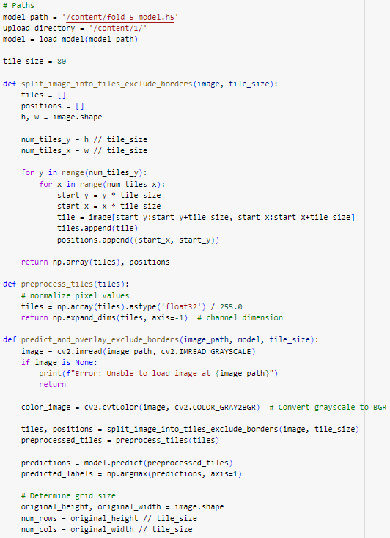

**Fig. 38**. New image splitting function

Following the splitting step, the program preprocesses each tile by normalizing its pixel values to a range of 0 to 1. This preprocessing step enhances the performance of the prediction model by standardizing the input data. Each preprocessed tile is then expanded to include a channel dimension, ensuring compatibility with the model's input requirements.

The pre-trained model, stored at /content/fold_5_model.h5, is loaded into memory and used to predict the content of each tile (Fig. 39). The prediction results are classified into two categories, 'ship' and 'no_ship,' based on the model's output probabilities. These predictions are then associated with their corresponding tile positions within the image.

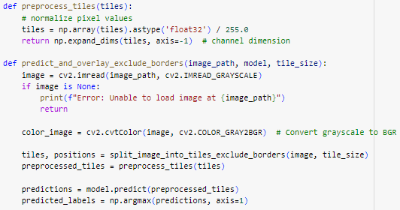

**Fig. 39.** New image normalization and prediction functions

### Results visualization

The visualization process is designed to present results in an intuitive and easily interpretable format. To achieve this, the program calculates a grid layout that displays tiles in the same spatial order as they appear in the original image (see Fig. 40).

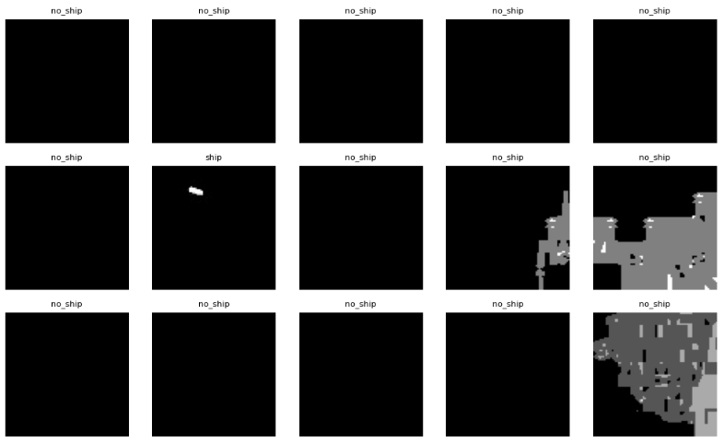

**Fig. 40**. A part of the prediction visualization in the first version

This method preserves the image's resolution and scale, allowing the output to closely resemble the input image. Such spatial consistency enhances clarity and facilitates seamless analysis.

Rather than adding text labels to individual tiles (like in Fig. 40), the renewed visualization employs a semi-transparent blue overlay to highlight tiles predicted to contain ships (Fig. 41). This approach improves visual recognition by emphasizing relevant regions without disrupting the underlying image details. The subtle blending of colors ensures a clear representation while maintaining aesthetic appeal, enabling rapid identification of areas of interest.

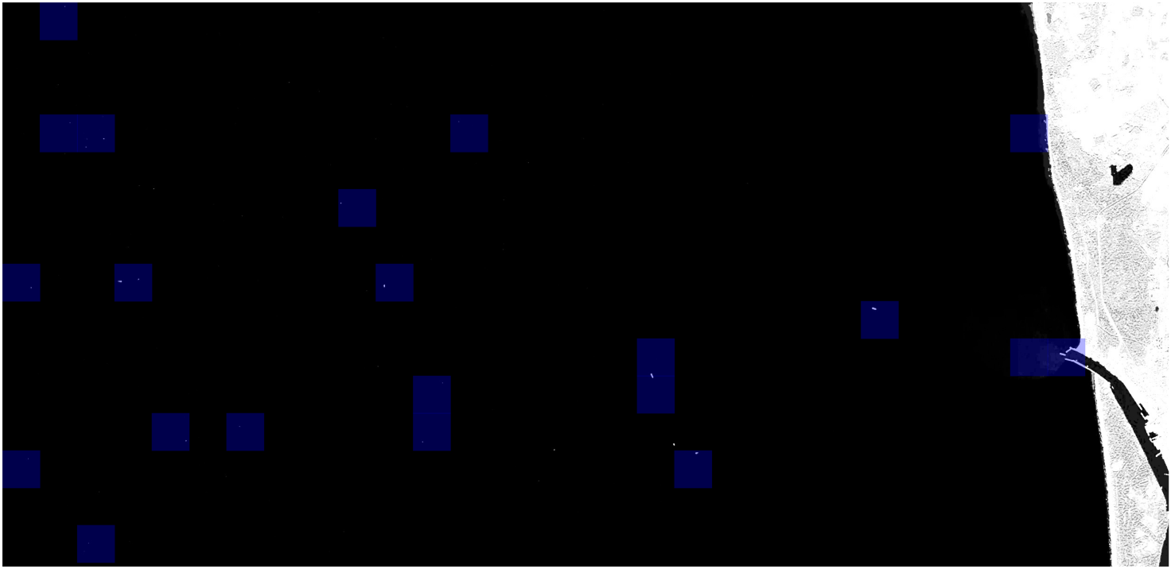

**Fig. 41.** Final look of the prediction visualization

## Model Testing

### Predictions for other Baltic Ports

The flexibility of the program lies in its ability to analyze satellite imagery from various Baltic ports seamlessly, without the need for modifications. This adaptability stems from the uniformity of the Copernicus program’s high-resolution satellite data, which provides consistent quality and structure across the entire Baltic Sea region. Since the imagery maintains the same structure and visual characteristics regardless of location, the program can seamlessly process data from different ports with ease.

While the model performs consistently across the region, there are potential nuances tied to the initial preprocessing stage. The inclusion of the SWIR (Short-Wave Infrared) layer, which reacts to temperature variations, introduces a factor of environmental dependency. As SWIR captures infrared data, it reflects the temperature of the waters, meaning that northern ports, with typically colder waters, might display slight differences in how the water is represented in the imagery (Fig. 42). However, in practice, this has a negligible effect on the model's accuracy. The robust design of the model enables it to effectively distinguish ships from surrounding water, regardless of subtle variations caused by temperature.

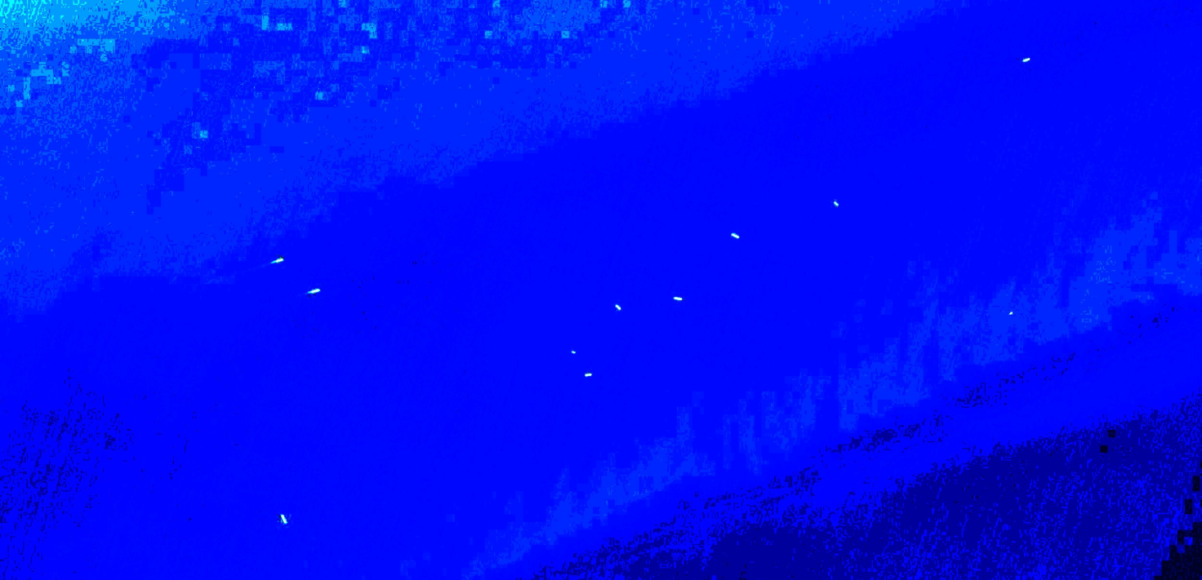

**Fig.42.** Tallinn‘s waters under SWIR layer in the colder months

Tests (see Fig. 43) have visually shown that the model ensures accuracy on images from ports it wasn’t trained on, proving its ability to generalize across the region. It achieves this by avoiding reliance on metadata like geographic coordinates, timestamps, or port-specific details. Instead, it focuses entirely on the visual elements within the images. This approach allows the model to maintain its reliability and effectiveness, no matter where the imagery comes from.

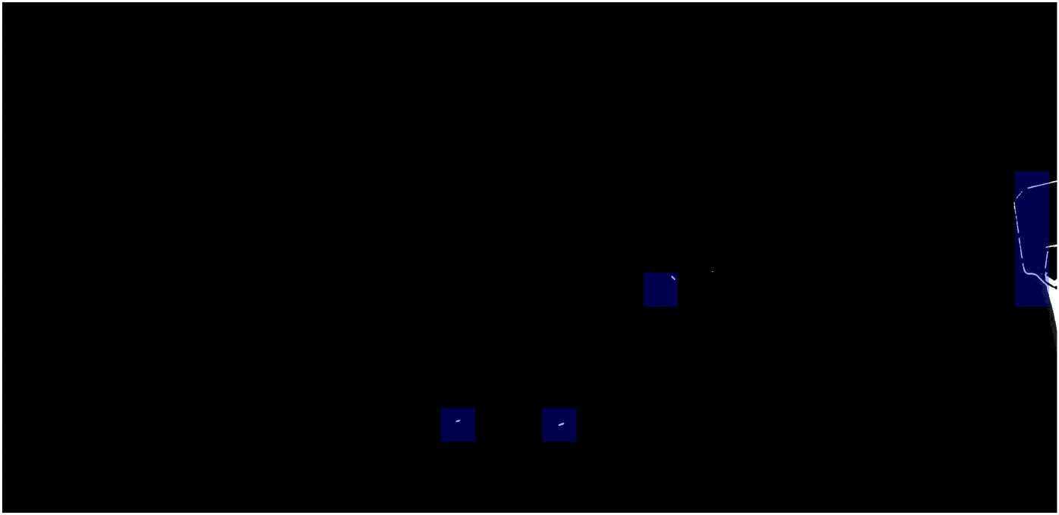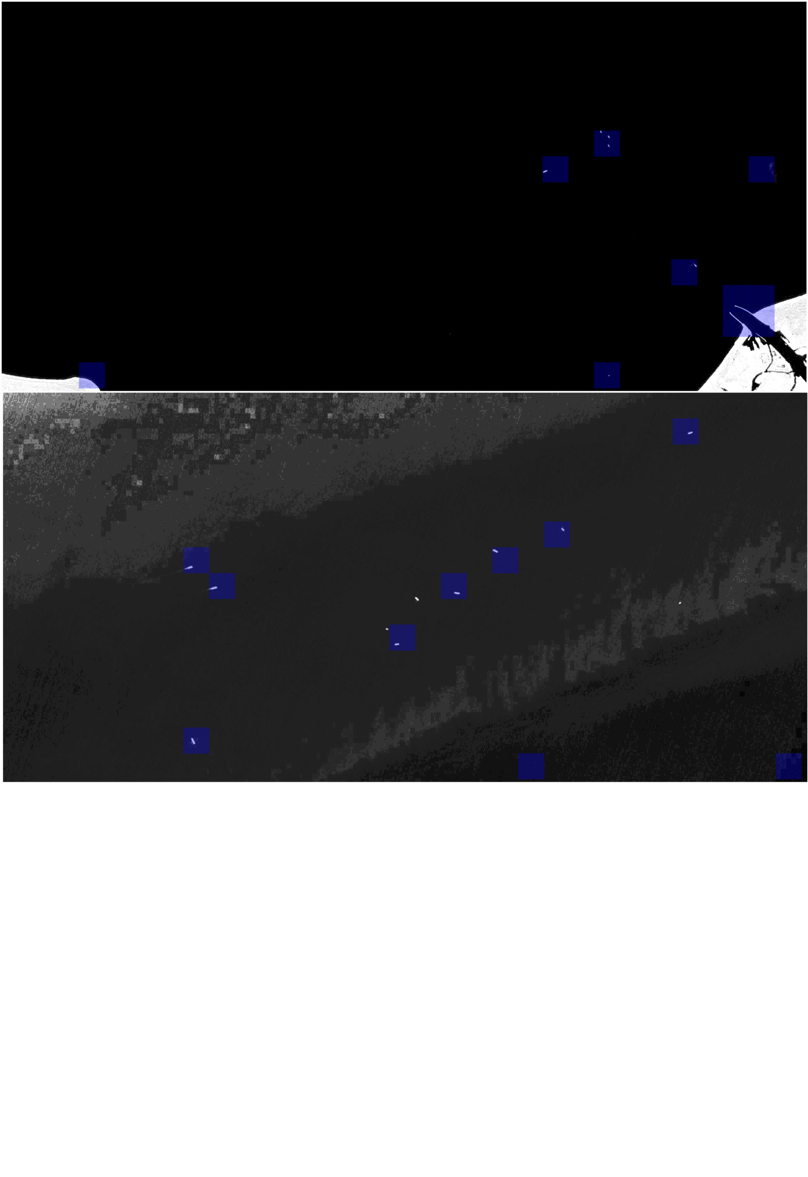

LIEPAJA

TALINN

RIGA

**Fig. 43.** Examples of predictions on Baltic ports

### Model performance metrics

The model performance metrics, averaged across the analyzed cases (Fig. 44.), demonstrate its strengths and limitations in ship detection tasks. The prediction accuracy averages approximately 98.65%, indicating that most tiles are correctly classified. However, the precision averages 49.75%, reflecting a higher occurrence of false positives (FP) due to the nature of the imagery and the model’s workflow. These false positives often arise when objects such as small, rice-shaped clouds or port berths resemble ships and appear fragmented across multiple tiles, leading to multiple mispredictions.

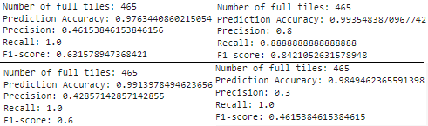

**Fig. 44.** Model performance metrics of predictions on Baltic ports

In contrast, the recall metric averages 97.22%, underscoring the model’s ability to correctly detect most actual ships in the dataset. This high recall is crucial, as the program is designed primarily as a surveillance and security tool, where missing ships is a greater concern than occasionally misclassifying non-ship objects. The F1-score, averaging 63.38%, combines precision and recall but is less representative in this scenario due to the low prevalence of ships relative to the total number of tiles.

Given the possible system's role as an additional layer of security rather than a standalone alarm system, these results are considered satisfactory. The program highlights tiles likely containing ships, enabling a human-in-the-loop approach where operators can review flagged regions for confirmation. This workflow enhances maritime monitoring by leveraging automation to streamline detection without sacrificing the human oversight needed to validate predictions and minimize false alarms.

## Current state of a program

The program's current capabilities provide a valuable tool for monitoring ship activity across the Baltic Sea. It achieves significant success in identifying where ships are located and where they are not, offering a clear advantage in simplifying maritime surveillance. However, it is important to note that the system is not entirely free from occasional "false alarms." This phenomenon, where the model identifies the presence of a ship in a tile when none actually exists, tends to occur more frequently under cloudier conditions or in environments with reduced visibility.

Given these nuances, the program is better suited as an additional layer of security rather than a standalone alarm system. Its output, highlighting tiles where ships are detected, can be forwarded to a responsible operator for review and testing. This approach ensures a *human-in-the-loop mechanism*, where the automated system streamlines the monitoring process, but the ultimate decisions rely on human oversight.

By focusing on parsing only relevant data, i.e. images with potential ship detections, rather than processing and analyzing entire swathes of water imagery, the program significantly reduces the workload of security personnel. This targeted approach not only enhances the efficiency of regional maritime surveillance but also strengthens the overall security framework by allowing humans to validate the automated results, ensuring a robust and reliable security system.

## Future opportunities and prospects

The development of this program marks a significant achievement, establishing a robust foundational model for ship detection across the Baltic Sea region. Its ability to analyze satellite imagery efficiently and provide accurate predictions demonstrates its potential as a valuable tool for maritime monitoring. However, as with any technological solution, there is always room for improvement and expansion. Future opportunities lie in refining its capabilities, exploring new applications, and addressing limitations mentioned below to unlock its full potential.

### Visual component

Currently, the program exists as a Python script, functioning without a dedicated visual representation or user interface. While it performs its tasks effectively, this lack of a front-end limits its accessibility and ease of use for operators who may not be familiar with coding environments. Introducing a user-friendly interface would be a pivotal step in enhancing the program’s usability and expanding its potential applications.

A well-designed interface would allow operators to interact with the model intuitively, enabling them to upload images, visualize predictions, and review results seamlessly. Such an interface could feature tools for zooming into specific regions, flagging tiles for closer inspection, and categorizing predictions for further analysis. Additionally, it could facilitate integration into existing maritime monitoring workflows, simplifying data processing and ensuring the program’s insights are actionable in real time.

### Weather dependency

Cloudy conditions are a significant challenge to the program, as the presence of clouds in satellite images can obscure key features or introduce visual noise, leading to reduced accuracy and an increase in false alarms. This limitation becomes especially apparent when the program incorrectly identifies cloud patterns as ships, which can compromise the reliability of its predictions.

One promising opportunity for overcoming this challenge is the implementation of artificial intelligence-based cloud removal techniques. Recent advancements in computer vision and deep learning have led to the development of specialized libraries and models capable of reconstructing obscured areas in satellite imagery by removing clouds.

A deeper investigations in such libraries would help to improve reliance of the model‘s predictions.

### Enhancement of features and capabilities

An exciting avenue for enhancing the model and program lies in the potential integration of high-resolution commercial satellite imagery. Unlike the current dataset, which offers sufficient detail for basic ship detection, commercial imagery provides significantly greater resolution and scale. This improvement could not only enhance the model's accuracy in detecting vessels but also enable it to undertake a more complex task: classifying the type of vessel.

Higher resolution images would capture finer details, such as the shape, size, and structural characteristics of ships, which are key indicators for differentiating between vessel types like bulk carriers, cargo ships, tankers, and fishing boats. By incorporating these details into the model's training dataset, the program could evolve from simply detecting the presence of ships to providing actionable insights about the nature of maritime activity in a given region.

Such a development would significantly broaden the program's applicability, making it an invaluable tool for maritime authorities, security agencies, and port operators. For example, distinguishing between commercial and non-commercial vessels could aid in monitoring shipping lanes, identifying unauthorized activity, or prioritizing port services. The ability to classify vessel types would elevate the program’s status from a detection tool to a comprehensive maritime monitoring system, capable of providing detailed and nuanced insights into regional maritime traffic.

## Conclusion of the section

The evaluation, testing, and optimization of the ship detection system have demonstrated its potential as a reliable tool for enhancing maritime monitoring and safety. Through systematic refinement of the model structure and hyperparameters, significant accuracy improvements were achieved, validating the robustness of the approach.

While the program has shown flexibility and adaptability across various geographic locations, challenges such as occasional false alarms and weather dependencies highlight areas for further enhancement. Future improvements, including the integration of advanced features and user-friendly interfaces, will broaden its applicability and usability, paving the way for more comprehensive and efficient ship detection solutions.

# CONCLUSIONS

1. The analysis of the subject and problem domain was performed highlighting the necessity for automating ship detection using satellite imagery and machine learning algorithms.
2. The existing sources of satellite imagery databases were analyzed, and Copernicus Data Space System was chosen as the main source due to its open-access nature and advanced functionality, including multilayered analysis in Copernicus image browser, **cloud coverage and other filters,** interactive timeline, etc. The machine learning algorithms and hyperparemeter optimization techniques were analyzed in detail as well.
3. The selected images of the Port of Klaipėda region were preprocessed to enhance key features, reduce noise, and prepare the data for machine learning workflows. The machine learning software system for ship detection using Copernicus satellite imagery and TensorFlow library was designed and implemented.
4. By refining the ship detection process and optimizing the model's structure and hyperparameters, the accuracy of the solution was significantly improved. In particular, it was observed that adjustments to hyperparameters, such as dropout rates and L2 regularization, and implementing of cross-validation, led to an increase in detection accuracy up to 97.78% on the testing set, from initial value being 91.68%.
5. Challenges such as reduced accuracy in cloudy conditions and occasional false alarms were identified, indicating areas for future refinement. Investigating techniques like AI-based cloud removal and leveraging commercial satellite imagery for enhanced resolution and ship classification are promising avenues for development. Furthermore, creating a user-friendly interface for operators would greatly improve usability and facilitate seamless interaction with the model's predictions.

# REFERENCES

* 1. Baltic wind. 2023. Ocean Winds and Ignitis Renewables to build the first offshore wind project in Lithuania. <https://balticwind.eu/oceans-wind-and-ignitis-renewables-to-build-the-first-offshore-wind-project-in-lithuania/>
  2. Ignitis Renewables. 2024. Lithuanian offshore wind farm. <https://ignitisrenewables.com/portfolio-item/lithuanian-offshore-wind-farm/>
  3. Rodl & Partner. 2022. Renewable energy project development in the Baltics. <https://www.roedl.com/insights/baltic-states-estonia-latvia-lithuania-projects-renewable-energy>
  4. Švietimo, mokslo ir sporto ministerija. 2023. Marine Valley. <https://smsm.lrv.lt/en/sector-activities/science-1/science_1/marine-valley/>
  5. Švietimo, mokslo ir sporto ministerija. 2023. Integrated Science, Studies and Business centres (Valleys). <https://smsm.lrv.lt/en/sector-activities/science-1/science_1/>
  6. Lithuanian Port of Klaipėda. 2023. Port of Klaipėda 2022 results: optimism despite a challenging year. <https://portofklaipeda.lt/en/naujienos/port-of-klaipeda-2022-results-optimism-despite-a-challenging-year/>
  7. EU-Conexus. 2023. Research For Society. <https://www.eu-conexus.eu/wp-content/uploads/2024/10/PPT-RFS_2023_compressed.pdf>
  8. Lithuanian Port of Klaipėda. 2024. Statistics. <https://portofklaipeda.lt/en/port/about-the-port-of-klaipeda/statistics/>
  9. Kaggle. 2018. Ships in Satellite Imagery. <https://www.kaggle.com/datasets/rhammell/ships-in-satellite-imagery/code?datasetId=2869>
  10. Kaggle. 2024. Boat Detection in Satellite images using Keras. <https://www.kaggle.com/code/daniellebagaforomeer/boat-detection-in-satellite-images-using-keras>
  11. Copernicus. 2024. Copernicus Dataspace. <https://dataspace.copernicus.eu/>
  12. Copernicus. 2024. Copernicus Browser [https://browser.dataspace.copernicus.eu/](https://browser.dataspace.copernicus.eu/?zoom=11&lat=55.74277&lng=20.92346&themeId=DEFAULT-THEME&visualizationUrl=U2FsdGVkX1%2BnAGEDe1GeOGByCn8IyARMHt%2BP2htBnF3xxLzct79CB%2BdFmz%2BLB6aBq1Yx1hsOZmNsFiH1c7DEZ0oLSnPdTMSahaCyOxaTm9gpgE9pYyhyqdXjqh1Z7Z%2FP&datasetId=S2_L2A_CDAS&fromTime=2024-08-07T00%3A00%3A00.000Z&toTime=2024-08-07T23%3A59%3A59.999Z&layerId=6-SWIR&gain=16.2&gamma=10&upsampling=BILINEAR&downsampling=BILINEAR&demSource3D=%22MAPZEN%22&cloudCoverage=30&dateMode=SINGLE)
  13. TensorFlow. 2024. ImageDataGenerator. [https://www.tensorflow.org/api_docs/python/tf/keras/  
      preprocessing/image/ImageDataGenerator](https://www.tensorflow.org/api_docs/python/tf/keras/preprocessing/image/ImageDataGenerator)
  14. PyTorch. 2023. ReduceLROnPlateau. [https://pytorch.org/docs/stable/generated/  
      torch.optim.lr_scheduler.ReduceLROnPlateau.html](https://pytorch.org/docs/stable/generated/torch.optim.lr_scheduler.ReduceLROnPlateau.html)
  15. EdmundOptics. 2024. What is SWIR. <https://www.edmundoptics.com/knowledge-center/application-notes/imaging/what-is-swir/>
  16. AirBus. 2024. Pleiades. <https://intelligence.airbus.com/imagery/our-optical-and-radar-satellite-imagery/pleiades/>
  17. Maxar. 2024. WorldView Legion. <https://www.maxar.com/worldview-legion>
  18. Géron, A. Hands-On Machine Learning with Scikit-Learn, Keras, and TensorFlow. O'Reilly Media, 2019.
  19. Chollet, F. Deep Learning with Python. Manning Publications, 2017.
  20. McKinney, W. Python for Data Analysis: Data Wrangling with Pandas, NumPy, and IPython. O'Reilly Media, 2017.
  21. Hunter, J. D. "Matplotlib: A 2D graphics environment." Computing in Science & Engineering, 2007.
  22. TensorFlow. 2024. Introduction to TensorFlow. <https://www.tensorflow.org/learn>
  23. Keras. 2024. Getting started with Keras. <https://keras.io/getting_started/>
  24. Scikit-learn. 2024. User Guide. <https://scikit-learn.org/stable/supervised_learning.html>
  25. Scikit-learn. 2024. Preprocessing. <https://scikit-learn.org/stable/modules/preprocessing.html>
  26. Scikit-learn. 2024. Tuning the hyper-parameters of an estimator. <https://scikit-learn.org/stable/modules/grid_search.html>
  27. Bergstra, J., & Bengio, Y. (2012). Random Search for Hyper-Parameter Optimization. Journal of Machine Learning Research. <https://jmlr.org/papers/v13/bergstra12a.html>
  28. Scikit-Optimize. Bayesian optimization library. <https://scikit-optimize.github.io/stable/>
  29. Ax platform by Meta. Bayesian optimization platform. <https://ax.dev/>
  30. Optuna. Official documentation. <https://optuna.org>
  31. Port Technology International. Port of Klaipeda surpasses 1mln TEU in record-breaking year. 2023. <https://www.porttechnology.org/news/port-of-klaipeda-surpasses-1-million-teu-in-record-breaking-year/>
  32. Port Technology International. Top 10 Baltic ports so far. 2022.<https://www.porttechnology.org/news/top-10-baltic-ports-in-2022-so-far/>
  33. GMK Center. Lithuanian port of Klaipeda increased its cargo turnover by 5% y/y in January-August. 2024<https://gmk.center/en/news/lithuanian-port-of-klaipeda-increased-its-cargo-turnover-by-5-y-y-in-january-august/>
  34. <https://portofklaipeda.lt/wp-content/uploads/2024/03/Port-of-Klaipeda-PERS-Environmental-Report-08032024-final-report.pdf>
  35. <https://portofklaipeda.lt/wp-content/uploads/2024/03/Port-of-Klaipeda-PERS-Environmental-Report-08032024-final-report.pdf>
  36. Port of Klaipeda. Year 2023 more successful than expected. 2024 <https://portofklaipeda.lt/en/naujienos/klaipeda-port-the-year-of-2023-were-more-successful-than-expected/>
  37. Delfi. Klaipėda port handled 18mn tons of cargo in H1. 2024. <https://www.delfi.lt/en/business/klaipeda-port-handled-18mn-tons-of-cargo-in-h1-90800365>
  38. Liepaja SEZ. Record-high cargo turnover in October this year. 2023. <https://liepaja-sez.lv/en/news/record-high-cargo-turnover-in-october-this-year/>
  39. Transport.LV. TOTAL CARGO TURNOVER AT THE LIEPAJA SEZ IN 2013.-2023. 2023. <https://transport.lv/en/ostas/liepajas-sez/>
  40. Latvian Public Broadcasting. Latvian port cargo turnover saw sharp drop in 2023. 2024. <https://eng.lsm.lv/article/economy/transport/22.01.2024-latvian-port-cargo-turnover-saw-sharp-drop-in-2023.a539832/>
  41. Viabaltica. Latvia port cargo turndown in h1 2024. <https://viabaltica.fi/latvia-port-cargo-turnover-down-11-in-h1-2024-statistics/>
  42. Freeport of Riga. 2024 10 month Cargo turnover at Freeport Riga. 2024. <https://rop.lv/sites/default/files/2024-11/Kravu%20apgroz%C4%ABjums_ENG%2C%2010.2024_0.pdf>
  43. Freeport of Riga. 2021 Cargo turnover at Freeport Riga. 2022. <https://rop.lv/sites/default/files/2022-01/Kravu%20apgroz%C4%ABjums_ENG_12.2021.pdf>
  44. Port of Talinn. Operational volumes for 2023 full year. 2024. <https://www.ts.ee/en/operational-volumes-for-2023-full-year/>
  45. Baltic Transport Journal. Port of Tallinn: 61,252 TEUs handled in Q1 2024 (+16.3% yoy). 2024. <https://baltictransportjournal.com/index.php?id=3159>
  46. Port of Talinn. Annual reports - 2021. 2022. <https://www.ts.ee/wp-content/uploads/2023/04/Tallinna-Sadam-Annual-Report-2021-copy.pdf>
  47. Port of Talinn. Annual reports - 2023. 2024. <https://www.ts.ee/wp-content/uploads/2024/04/Tallinna_Sadam_Annual_Report_2023.pdf>
  48. Object Detection in Large Satellite Imagery Using Deep Learning. MathWorks Documentation, 2024. <https://www.mathworks.com/help/vision/ug/object-detection-in-large-satellite-imagery-using-deep-learning.html#ObjectDetectionInLargeSatelliteImageryUsingDeepLearningExample-6>
  49. Using a Confusion Matrix to Calculate Precision and Recall. Keylabs.ai, Sep. 30, 2024.

<https://keylabs.ai/blog/using-a-confusion-matrix-to-calculate-precision-and-recall/>

# APPENDIXES

**Appendix 1. „Boat Detection in Satellite Images Using Keras“** Notebook regarding Ships in Satellite imagery dataset from Kaggle:

|  |
| --- |
| # -*- coding: utf-8 -*- """notebook9f95999dbf  Automatically generated by Colab.  Original file is located at  https://colab.research.google.com/#fileId=https%3A//storage.googleapis.com/kaggle-colab-exported-notebooks/notebook9f95999dbf-500d420c-6cdf-4e41-a29d-d8c5d298e568.ipynb%3FX-Goog-Algorithm%3DGOOG4-RSA-SHA256%26X-Goog-Credential%3Dgcp-kaggle-com%2540kaggle-161607.iam.gserviceaccount.com/20241211/auto/storage/goog4_request%26X-Goog-Date%3D20241211T124040Z%26X-Goog-Expires%3D259200%26X-Goog-SignedHeaders%3Dhost%26X-Goog-Signature% """  # IMPORTANT: RUN THIS CELL IN ORDER TO IMPORT YOUR KAGGLE DATA SOURCES, # THEN FEEL FREE TO DELETE THIS CELL. # NOTE: THIS NOTEBOOK ENVIRONMENT DIFFERS FROM KAGGLE'S PYTHON # ENVIRONMENT SO THERE MAY BE MISSING LIBRARIES USED BY YOUR # NOTEBOOK. import kagglehub rhammell_ships_in_satellite_imagery_path = kagglehub.dataset_download('rhammell/ships-in-satellite-imagery')  print('Data source import complete.')  # This Python 3 environment comes with many helpful analytics libraries installed # It is defined by the kaggle/python Docker image: https://github.com/kaggle/docker-python # For example, here's several helpful packages to load  import numpy as np # linear algebra import pandas as pd # data processing, CSV file I/O (e.g. pd.read_csv)  # Input data files are available in the read-only "../input/" directory # For example, running this (by clicking run or pressing Shift+Enter) will list all files under the input directory  import os for dirname, _, filenames in os.walk('/kaggle/input'):  for filename in filenames:  os.path.join(dirname, filename)  # You can write up to 20GB to the current directory (/kaggle/working/) that gets preserved as output when you create a version using "Save & Run All" # You can also write temporary files to /kaggle/temp/, but they won't be saved outside of the current session  !pip install visualkeras  # Commented out IPython magic to ensure Python compatibility. import warnings warnings.filterwarnings("ignore")  import pandas as pd import numpy as np import matplotlib.pyplot as plt import matplotlib.image as mpimg import seaborn as sns # %matplotlib inline import os import tensorflow as tf np.random.seed(2)  from sklearn.model_selection import train_test_split from sklearn.metrics import confusion_matrix import itertools  from keras.utils import to_categorical from keras.models import Sequential from keras.layers import Dense, Conv2D , MaxPool2D , Flatten , Dropout , BatchNormalization from keras.optimizers import RMSprop from tensorflow.keras import layers from keras.callbacks import ReduceLROnPlateau  """# Labelling Data  - No ship = 0 - Ship = 1 """  label_number = {'No_ship' : 0, 'Ship' : 1} label_word = ['No_ship', 'Ship']  """# About the Dataset : Ships in Satellite Imagery  ## Context  Satellite imagery provides unique insights into various markets, including agriculture, defense and intelligence, energy, and finance. New commercial imagery providers, such as Planet, are using constellations of small satellites to capture images of the entire Earth every day.  This flood of new imagery is outgrowing the ability for organizations to manually look at each image that gets captured, and there is a need for machine learning and computer vision algorithms to help automate the analysis process.  The aim of this dataset is to help address the difficult task of detecting the location of large ships in satellite images. Automating this process can be applied to many issues including monitoring port activity levels and supply chain analysis.  ## Content  The dataset consists of images extracted from Planet satellite imagery collected over the San Francisco Bay and San Pedro Bay areas of California. It includes 4000 80x80 RGB images labeled with either a "ship" or "no-ship" classification. Images were derived from PlanetScope full-frame visual scene products, which are orthorectified to a 3-meter pixel size.  Provided is a zipped directory shipsnet.zip that contains the entire dataset as .png images. Each individual image filename follows a specific format: {label} _ {scene id} _ {longitude} _ {latitude}.png  - label: Valued 1 or 0, representing the "ship" class and "no-ship" class, respectively. - scene id: The unique identifier of the PlanetScope visual scene the image was extracted from. The scene id can be used with the Planet API to discover and download the entire scene. - longitude_latitude: The longitude and latitude coordinates of the image center point, with values separated by a single underscore. The dataset is also distributed as a JSON formatted text file shipsnet.json. The loaded object contains data, label, scene_ids, and location lists.  The pixel value data for each 80x80 RGB image is stored as a list of 19200 integers within the data list. The first 6400 entries contain the red channel values, the next 6400 the green, and the final 6400 the blue. The image is stored in row-major order so that the first 80 entries of the array are the red channel values of the first row of the image.  The list values at index i in labels, scene_ids, and locations each correspond to the i-th image in the data list.  ## Class Labels  The "ship" class includes 1000 images. Images in this class are centered on the body of a single ship. Ships of different sizes, orientations, and atmospheric collection conditions are included. Example images from this class are shown below.  ![](https://i.imgur.com/tLsSoTz.png)   The "no-ship" class includes 3000 images. A third of these are a random sampling of different land cover features - water, vegetation, bare earth, buildings, etc. - that do not include any portion of a ship. The next third are "partial ships" that contain only a portion of a ship, but not enough to meet the full definition of the "ship" class. The last third are images that have previously been mislabeled by machine learning models, typically caused by bright pixels or strong linear features. Example images from this class are shown below.  ![](https://i.imgur.com/cyG2Z54.png)  ## Scenes  Eight full-scene images are included in the scenes directory. Scenes can be used to visualize the performance of classification models trained on the dataset. Verify a model's accuracy by applying it across a scene and viewing where 'ship' classifications occur - the context provided by the scene helps determine positive hits from false alarms. An example scene is shown below.   ## Acknowledgements  Satellite imagery used to build this dataset is made available through Planet's Open California dataset, which is openly licensed. As such, this dataset is also available under the same CC-BY-SA license. Users can sign up for a free Planet account to search, view, and download their imagery and gain access to their API.  [](http://) """  dataframed = pd.DataFrame(columns = ['path', 'label', 'scene_id', 'longitude', 'latitude']) scenes = pd.DataFrame(columns = ['path', 'label'])  dataframes = [dataframed] for x in range(0, len(dataframes)):  temp = '/kaggle/input/ships-in-satellite-imagery/shipsnet/shipsnet/'  for dirname, _, filenames in os.walk(temp) :  for filename in filenames :  path = os.path.join(dirname, filename)  name = filename  splitter = name.split('_')  path = os.path.join(dirname, filename)  label = int(splitter[0])  scene_id = splitter[2] + '_' + splitter[3] + '_' + splitter[4]  longitude = splitter[6]  latitude = splitter[7].rstrip('.png')  dataframes[x].loc[len(dataframes[x])] = [temp + '/' + name, label, scene_id, longitude, latitude]  dataframes = [scenes] for x in range(0, len(dataframes)):  temp = '/kaggle/input/ships-in-satellite-imagery/scenes/scenes/'  for dirname, _, filenames in os.walk(temp) :  for filename in filenames :  path = os.path.join(dirname, filename)  name = filename  path = os.path.join(dirname, filename)  dataframes[x].loc[len(dataframes[x])] = [temp + '/' + name, filename]  dataframed.head()  """# Dataset consists of :  - **8 Scenes = 4000 images** """  print("Shape of the Dataset =", dataframed.shape)  """# Sample Images : Scenes (8 Samples)"""  import matplotlib.image as mpimg  for x in range(0, 8) :  img = mpimg.imread(scenes.iloc[int(x)]['path'])  plt.subplots()  plt.imshow(img)  plt.title("Scene " + str(x + 1))  """# Sample Images : No ships (10 Samples)"""  import matplotlib.image as mpimg listed = list(np.where(dataframed["label"] == 0)) listed = listed[0].tolist() for x in range(0, 10) :  img = mpimg.imread(dataframed.iloc[int(listed[x])]['path'])  plt.subplots()  plt.imshow(img)  plt.title("No ships")  """# Sample Images : Ships (10 Samples)"""  import matplotlib.image as mpimg listed = list(np.where(dataframed["label"] == 1)) listed = listed[0].tolist() for x in range(0, 10) :  img = mpimg.imread(dataframed.iloc[int(listed[x])]['path'])  plt.subplots()  plt.imshow(img)  plt.title("Ships")  """# Split The Data for Training and Testing Purposes  **Test Sizes**  - 20% """  from sklearn.model_selection import train_test_split  train, test = train_test_split(dataframed, test_size=0.2, random_state = 42)  """# Contents of Training Data"""  train.head()  """# Contents of Testing Data"""  test.head()  """# Preprocessing Image Data"""  import cv2 import numpy as np import pandas as pd  def size_regulator(df, image_column='path', target_size=(80, 80)):  images = []  for path in df[image_column]:  image = cv2.imread(path, cv2.IMREAD_GRAYSCALE)  image = cv2.resize(image, target_size)  images.append(image)  return np.array(images)  X_Train = size_regulator(train) X_Test = size_regulator(test)  y_Train = train y_Test = test  y_Train = y_Train.drop(['path', 'scene_id', 'longitude', 'latitude'], axis=1) y_Test = y_Test.drop(['path', 'scene_id', 'longitude', 'latitude'], axis=1)  y_Train.head()  y_Train_encoded = to_categorical(y_Train)  y_Test.head()  y_Test_encoded = to_categorical(y_Test)  y_Train_encoded = np.asarray(y_Train_encoded).astype('float32').reshape((-1,1)) y_Test_encoded = np.asarray(y_Test_encoded).astype('float32').reshape((-1,1))  X_Train = X_Train.reshape(-1, 80, 80, 1) y_Train = np.array(y_Train)   X_Test = X_Test.reshape(-1, 80, 80, 1) y_Test_np = np.array(y_Test)  print("images in Train Shape = ", X_Train.shape) print("images in Test Shape = " , X_Test.shape)  """# Keras Model : Satellite_Boat_Detection  Consists of 19 layers :  1. **AL : 2D Convolution Layer** 2. **AL : Batch Normalization** 3. **AL : 2D Max Pooling Operation** 4. **AL : 2D Convolution Layer** 5. **AL : Dropout Layer (0.1)** 6. **AL : Batch Normalization** 7. **AL : 2D Max Pooling Operation** 8. **AL : 2D Convolution Layer** 9. **AL : Batch Normalization** 10. **AL : 2D Max Pooling Operation** 11. **AL : 2D Convolution Layer** 12. **AL : Dropout Layer (0.2)** 13. **AL : Batch Normalization** 14. **AL : 2D Max Pooling Operation** 15. **AL : 2D Convolution Layer** 16. **AL : Flatten Layer** 17. **AL : Densely-connected NN Layer** 18. **AL : Dropout Layer (0.2)** 19. **AL : Densely-connected NN Layer** """  Boat_Detection = Sequential()  Boat_Detection.add(Conv2D(32 , (3,3) , strides = 1 , padding = 'same' , activation = 'relu' , input_shape = (80,80,1))) Boat_Detection.add(BatchNormalization()) Boat_Detection.add(MaxPool2D((2,2) , strides = 2 , padding = 'same')) Boat_Detection.add(Conv2D(64 , (3,3) , strides = 1 , padding = 'same' , activation = 'relu')) Boat_Detection.add(Dropout(0.1)) Boat_Detection.add(BatchNormalization()) Boat_Detection.add(MaxPool2D((2,2) , strides = 2 , padding = 'same')) Boat_Detection.add(Conv2D(64 , (3,3) , strides = 1 , padding = 'same' , activation = 'relu')) Boat_Detection.add(BatchNormalization()) Boat_Detection.add(MaxPool2D((2,2) , strides = 2 , padding = 'same')) Boat_Detection.add(Conv2D(128 , (3,3) , strides = 1 , padding = 'same' , activation = 'relu')) Boat_Detection.add(Dropout(0.2)) Boat_Detection.add(BatchNormalization()) Boat_Detection.add(MaxPool2D((2,2) , strides = 2 , padding = 'same')) Boat_Detection.add(Conv2D(256 , (3,3) , strides = 1 , padding = 'same' , activation = 'relu')) Boat_Detection.add(Dropout(0.2)) Boat_Detection.add(BatchNormalization()) Boat_Detection.add(MaxPool2D((2,2) , strides = 2 , padding = 'same')) Boat_Detection.add(Flatten()) Boat_Detection.add(Dense(units = 128 , activation = 'relu')) Boat_Detection.add(Dropout(0.2)) Boat_Detection.add(Dense(units = 1 , activation = 'sigmoid'))  Boat_Detection.compile(optimizer = "rmsprop" , loss = 'binary_crossentropy' , metrics = ['accuracy'])  Boat_Detection.summary()  learning_rate_callback = ReduceLROnPlateau(monitor='val_accuracy', patience = 2, verbose=1,factor=0.3, min_lr=0.000001)  history = Boat_Detection.fit(X_Train, y_Train, batch_size = 32, epochs = 12)  """# Loss and Accuracy Metrics"""  print("Loss of the model is - " , Boat_Detection.evaluate(X_Test,y_Test)[0]) print("Accuracy of the model is - " , Boat_Detection.evaluate(X_Test,y_Test)[1]*100 , "%")  """# Testing Dataset Predictions"""  import numpy as np listed = list(np.where(dataframed)) listed = listed[0].tolist() listed = list(set(listed)) y1 = Boat_Detection.predict(X_Test) for x in range(0, 50) :  plt.subplots()  plt.imshow(X_Test[x])  prediction_answer = int(np.round(y1[x]))  plt.title("Predicted label :{}\nTrue label :{}".format(label_word[prediction_answer], label_word[y_Test.iloc[int(listed[x])]['label']])) |